**Environmental filtering obscures microbial indicators of glacier melt in groundwater-fed alpine springs and streams**

**0 Abstract**

Mountain-block recharge (MBR) is a complex hydrological process connecting glacier ice to downstream ecosystems via deep subsurface flowpaths. Unresolved interactions between mountain glaciers and groundwater limit our ability to predict how alpine watersheds will respond to glacier retreat. Though microbial communities in groundwater-fed springs and streams may serve as bioindicators of glacial recharge in MBR, their sensitivity to subsurface glacier sourcing remains unclear. Here, we evaluated microbial bioindicator potential across two glacier-covered mountain systems: Mount Hood and Glacier National Park, USA. Using pre-existing data from Miller et al. (2021), we tested associations between 16S and 18S rRNA amplicon sequences, isotope-based glacier source contributions (fᵢ), and environmental parameters from 59 alpine springs and streams. We aimed to (i) determine whether microbial community compositions reflect subsurface-routed glacial meltwater and (ii) identify environmental factors most strongly associated with 16S and 18S taxonomy. Microbial diversity and composition did not consistently reflect fᵢ. Rather, communities were more strongly explained by solute concentrations, temperature, redox conditions, and unmodeled processes along discrete flowpaths. Our results suggest that environmental filtering may obscure microbial signals of glacial recharge, limiting the utility of sampled communities as bioindicators of fi in MBR. Nevertheless, our findings provide insights into how subsurface hydrochemistry and catchment conditions affect microbial ecology across retreating mid-latitude mountain glaciers.

**1 Introduction**

The movement of glacier meltwater through deep subsurface flowpaths plays a key role in determining how montane watersheds respond to climate warming. Liquid water stored in glacier ice and snowpack is released during seasonal melting, supplying downstream water flow during warmer, drier periods (Immerzeel et al., 2020). These catchments support ~22% of the global population (Immerzeel et al., 2020) and sustain proglacial ecosystems by delivering nutrients and promoting biodiversity (Losapio et al., 2025). While meltwater was traditionally believed to travel downstream via surface runoff or shallow aquifers, Miller et al. (2021) – for example – found that a significant portion may instead infiltrate porous bedrock and groundwater networks via mountain-block recharge (MBR). Water flow from MBR sustains perennial spring flow and stream baseflow, yet glacier-groundwater interactions remain difficult to constrain (van Tiel et al., 2024). With ~34% of alpine glacier mass projected to disappear by 2050 (Cook et al., 2023; IPCC, 2019), it is critical to determine whether MBR preserves a detectable glacier melt signature, and whether this signature can predict the dependence of proglacial ecosystems on this vulnerable water source.

Stable water isotopes (δ18O and δ2H) are commonly used to infer recharge sources across alpine catchments (e.g., Baraer et al., 2015; Tolley et al., 2015; Wagner et al., 2021), but often cannot reliably distinguish glacier melt versus seasonal snowfall (Wanner et al., 2023). This limitation arises from overlapping isotope compositions and fractionation during snowpack evolution (Beria et al., 2018). As a result, indicators such as microbial community composition have emerged as promising alternatives (e.g., Miller et al., 2021; Sugiyama et al., 2018; URycki et al., 2022). Taxa associated with glacier melt recharge have been detected in alpine springs and streams, suggesting that microbial communities may act as biosignatures of glacial influence where isotopic resolution is limited (Miller et al., 2021). If glacier-associated taxa persist through MBR, they could improve our understanding of how influential glacier melt is on groundwater-fed alpine ecosystems and predict ecological responses to deglaciation.

Microorganisms in glacier habitats experience cold, nutrient-poor, water-limited, and variable redox conditions (Hotaling et al., 2017; Varliero et al., 2023). These conditions select for extremophilic taxa that differ from those in microbial communities found at lower-elevations. Supraglacial and subglacial microorganisms support carbon fixation, organic matter degradation, and carbon, nitrogen, and sulfur cycling (e.g., Boyd et al., 2014; Crosta et al., 2025; Dunham et al., 2021; Havig & Hamilton, 2019; Lemarche-Gagnon et al., 2021). Exported in meltwater, microbial cells and metabolites like dissolved organic matter can influence nutrient fluxes, community composition, and food webs downstream (Kohler et al., 2022; Milner et al., 2017). However, environmental filtering – through redox gradients, physical conditions, geochemistry, connectivity, and residence times – may obscure microbial signals as meltwater enters the subsurface (URycki et al., 2022). While this filtering, along with random dispersal, may limit the reliability of microbiomes as indicators of glacial recharge, it remains unclear whether glacier-originating taxa and aquatic conditions persist through deep subsurface flowpaths and support a detectable biosignature downstream.

In this study we expanded on observations by Miller et al. (2021) using amplicon sequence data (16S and 18S rRNA), fractional contributions of glacier ice (fi), and environmental measurements that they previously generated from alpine springs and streams across two mountain glacier systems: Mount Hood, Oregon (MH), and Glacier National Park, Montana (GNP). We sought to evaluate whether microbial communities act as bioindicators of fi in MBR. We hypothesized that higher fi would associate with distinct microbial communities enriched in cryosphere-adapted taxa. However, we expected this signal to differ between MH and GNP per differences in subsurface hydrology and bedrock porosity.

**2 Methods**

**2.1 Study sites, published sampling methods, and prior analyses**Field sampling, isotopic analysis, and DNA extractions were previously conducted and published in Miller et al. (2021). Their study described protocols for collecting and interpreting spring, stream, and end-member water samples (rain, snow, and glacier ice) across Mount Hood (MH), Oregon, and Glacier National Park (GNP), Montana (**Figure 1**). Differences in bedrock lithology, meteorology, and glacier extent between MH and GNP influence subsurface recharge and hydrologic connectivity (Miller et al., 2021). Building on Miller et al. (2021), we analyzed pre-existing 16S and 18S SSU rRNA data to test whether microbial communities reflect fractional glacier ice contributions (fᵢ) and, in turn, indicate MBR across spatial, physical, and geochemical gradients. Protocols for nucleic acid preparation, amplification, sequencing, and mothur-based processing (e.g., quality control, alignment, and classification) may be found in Miller et al. (2021) and clarified upon request.

**2.2 Geochemical analysis**

Aqueous chemistry samples collected by Miller et al. (2021; unpublished) were analyzed at the New Mexico Bureau of Geology and Mineral Resources via ion chromatography and inductively coupled plasma optical emission spectrometry using EPA methods (Method 300.0 and 200.7, respectively). This analysis was completed within two months of collection. We provided a complete summary of aqueous geochemistry results (mg/L) and sampling dates in **Supplementary Table S1**. Additionally, *in situ* measurements of temperature, pH, conductivity, turbidity, dissolved oxygen, and oxidation-reduction potential (ORP) were gathered using a YSI Professional Plus multiparameter meter (YSI, Inc.).

**2.3 Community analysis & statistics**

All statistical analyses were performed in R (v4.5.0) and applied to microbial taxonomy, abundance, and metadata imported via *phyloseq* (McMurdie & Holmes, 2013; e.g., Sauer et al., 2022). Mitochondrial and chloroplast 16S rRNA sequences were removed, yielding a 16S rRNA dataset of 1,321,878 reads (63,059 operational taxonomic units, or OTUs) across 88 samples (59 unique spring and stream sites). The 18S dataset consisted of 2,336,959 reads (27,294 OTUs) across 55 samples (43 unique sites) All R scripts and processed data will be available on GitHub upon publication or by request.

2.3.1 Environmental variability

We used principal component analysis (PCA) – presented as a biplot (*ggbiplot*) (Vu, 2011) – to visualize environmental differences across spring and stream samples (n = 50; 17 GNP, 33 MH). Metrics included fᵢ, elevation, temperature, pH, oxidation-reduction potential (ORP), specific conductance (SPC), total dissolved solids (TDS), alkalinity (CaCO3), and a variety of solute concentrations (mg/L), including Cl-, Sr2+, K+, Mg2+, SiO2, DO, Na+, SO42-, HCO3-, and Ca2+. Right-skewed distributions were log10(x)-transformed. Highly collinear variables (Pearson’s r > 0.9) were excluded: HCO3-, CaCO3, SPC, and Mg2+ were removed due to near-linear relationships with Ca2+; TDS due to collinearity with Sr2+; and both Cl- and K+ due to their correlation with Na+ (**Figure S1**). Despite high collinearity and a similar role when tracing subsurface geochemistry and hydrology (e.g., Fields & Dethier, 2019), SiO2 and Na+ concentrations were retained. We made this choice because SiO2 is implicated in silicate weathering processes and microbial-mineral interactions (e.g., Ghezzi et al., 2022), and Na+ showed a distinct correlation with Cl-, while Cl- and SiO2 remained below the collinearity threshold. We tested for significant differences by location (MH, GNP) using PERMANOVA (adonis2, 999 permutations; *vegan*) on a Euclidean distance matrix (Oksanen et al., 2018). Dispersion within groups was compared using PERMDISP (betadisper; 999 permutations).

2.3.2 Alpha diversity

We calculated observed richness (number of unique OTUs) and Shannon’s diversity (richness and the evenness of relative OTU abundances) to assess differences in within-site community structure, or alpha diversity. After removing singleton OTUs (OTUs observed once across all 88 samples) and filtering the 16S dataset to spring and stream samples only, we removed samples with < 7,000 reads. We selected this threshold due to a marked drop in sequence depth below the new minimum (7,232) (**Figure S2A**). Rarefaction was then performed at 7,232 reads to address uneven sequencing efforts (Schloss & McMahon, 2024). Our rarefied 16S rRNA dataset contained 347,136 reads (16,494 OTUs) from 48 spring and stream samples (29 MH, 19 GNP). For 18S, samples with < 20,000 reads were excluded. Rarefaction at the new minimum read count (31,552) produced 788,800 reads (7,811 OTUs) across 25 samples (15 MH, 10 GNP) (**Figure S2B**).

Observed richness and Shannon’s diversity were calculated in *phyloseq* and compared across locations using a t-test or Wilcox rank sum test if data were parametric or non-parametric, respectively. We also tested correlations between fᵢ and diversity metrics using Pearson’s product-moment correlation and two-tailed permutation tests (9,999 iterations). A Welch’s t-test compared mean fᵢ in MH and GNP. Replicate 16S samples (n = 2–3 for 12 of 34 unique sites) and 18S samples (n = 2 for 6 of 19 unique sites) were treated as independent. To determine whether aggregating our findings skewed our conclusions, we averaged 16S alpha diversity values by site and compared these statistical outcomes to non-aggregated findings. Negligible differences in p-values, effect sizes, and standard deviations supported our decision. Furthermore, our non-aggregated datasets (16S and 18S) may better represent within-site heterogeneity (**Figures S3, S4**).

We adapted a supervised machine learning framework to determine how rarefied 16S and 18S community compositions covaried with 18 environmental metrics described in *2.3.1 Environmental variability* (Sperlea et al., 2021). Briefly, untransformed environmental metrics were binned into tertiles for indicator species analysis (*IndVal*). Taxa associated with upper and lower tertiles of each metric were identified using multipatt from the *indicspecies* package (p < 0.05) (Cáceres & Legendre, 2009). Abundance data were then Hellinger-transformed and used to train RandomForest models predicting environmental metrics across sites using the differential abundances of microbial taxa. Model performance, or predictive power, was evaluated by calculating the coefficient of determination (R2, a metric for covariation) between observed and predicted values. A 10-fold cross-validation and triplicate runs were used to improve reliability. In certain cross-validation folds, the model output was generated using ≤ 5 unique values, causing a warning message to appear when running our modified Sperlea et al. (2021) script. Regression was still performed in these cases to maintain consistency across analyses. Additionally, instances of R2, Root Mean Squared Error (RMSE), and Mean Absolute Error values are reported in **Supplementary** **Table S2** and **S3**.

To identify differentially abundant 16S taxa, we used linear discriminant analysis effect size (LEfSe) on the rarefied relative abundance dataset (Segata et al., 2011). Comparisons were made across recharge sources, locations, and eastern vs. western-facing sites at MH (LDA > 2.5; p < 0.01). For recharge source, spring/stream samples were classified as glacially influenced if fᵢ exceeded 0.60 – a threshold previously identified through sensitivity analysis (Miller et al., 2021) – while samples below this cutoff were considered precipitation influenced. Despite known risks of false positives (Nearing et al., 2022), LEfSe is an effective tool commonly used in exploratory environmental microbiology studies (e.g., Guo et al., 2024; Lamarche-Gagnon et al., 2024). Analyses were completed using the *MicrobiomeMarker* package (Cao et al., 2022). GNP sites were excluded from recharge-source analysis due to narrow fᵢ ranges. We used a more permissive LDA threshold than recent studies (e.g., > 3.5) to detect broader patterns in 16S taxonomy. Mean relative abundances reported for predominant taxa were calculated using non-rarefied, relative abundance-normalized data to more accurately present actual taxa abundances across communities (**Supplementary Tables S4** and **S5**).

2.3.3 Beta diversity

To examine between-site differences in community composition (beta diversity), we applied a variance-stabilizing transformation (VST) to unrarefied 16S and 18S datasets. This method normalizes variance across abundance levels, reducing noise and increasing eigengap values to better resolve differences in community structure (Badri et al., 2020). Samples with >5,000 reads were retained. Our working 16S and 18S VST datasets contained 19,294 and 8,408 OTUs from 49 (29 MH, 20 GNP) and 29 (17 MH, 12 GNP) spring/stream samples, respectively.

16S replicates (n = 2–3 for 12 of 35 sites) and 18S replicates (n = 2 for 7 of 22 sites) were treated as independent due to within-site variation (**Figure S5**, **Table S6**). Note, the same environmental measurements were used for each biological replicate (**Table S1**). PCA was used to visualize differences in community composition. Environmental variables significantly associated with PC1 and PC2 (p < 0.05) were identified via linear regression and redundancy analysis in *vegan* (9,999 permutations, Bonferroni-corrected) (Oksanen et al., 2020). We evaluated differences by location (MH vs. GNP) and eastern- and western-facing aspects of MH using PERMANOVA (adonis2), comparing within-group dispersion through PERMDISP. Hierarchical clustering (ward.D2) on Bray-Curtis dissimilarities allowed us to resolve overlap between MH and GNP samples and visualize clustering by primary recharge sources.

**3 Results**

**3.1 Environmental variability**

We first characterized underlying sourcing, physical, and geochemical conditions in spring and stream samples. In the PCA, we observed significant abiotic differences between MH and GNP (F = 20.19, R2 = 0.34, p = 0.001). A biplot shows the directionality of these differences: GNP and MH clusters separated along PC1 and PC2 due to higher SiO2 and ORP in the MH samples, and greater fi, pH, and elevations in the GNP samples (**Figure 2**). Several measurements (e.g., Sr2+, temperature, SO42-, Ca2+, DO, HCO3-, CaCO3, SPC, and Mg2+) mainly contributed to PC1, suggesting environmental differences between individual sites at both MH and GNP. Among the environmental variables, dissolved oxygen (DO) showed a modest inverse relationship with Sr2+, temperature, Ca2+, and their collinear solutes. Four MH sites classified as warm springs by Miller et al. (2021) noticeably differed from other springs. For example, these thermally active sites (>18 °C) had the highest SPC values recorded (463–1247 μS/cm).

**3.2 16S alpha diversity**

We calculated alpha diversity in rarefied bacterial and archaeal (16S) communities using two metrics: observed richness and Shannon’s diversity. On average, MH sites contained 1,560 unique OTUs (sd = 579) with a Shannon’s diversity of 6.13 (sd = 0.88), whereas GNP sites hosted 983 OTUs (sd = 392) and a Shannon’s diversity of 5.57 (sd = 0.70) **(Figure 3**). Both richness (t = -3.81, p = 0.0004) and Shannon’s diversity (W = 139, p = 0.003) were significantly higher in MH than GNP. Neither metric significantly correlated with fᵢ at either location (**Figure 4**). This lack of correlation is noteworthy since GNP spring and stream samples had significantly higher fᵢ values than MH (mean difference = 0.34, t = 6.09, p = 2.7e-7).

We used a supervised machine learning framework (RandomForest modeling) to determine how well 16S community composition covaried with fᵢ, physical parameters, and geochemical conditions. At MH, covariation was moderate overall (mean R2 = 0.52; **Figure 5**). Predictive power was highest for temperature and several solutes connected to bedrock weathering, including Mg2+, SiO2, Na+, SO42-, CaCO3, HCO3-, TDS, Ca2+, and SPC. In contrast, elevation, ORP, pH, and fᵢ showed below-average predictive power. At GNP, covariation was generally weak (mean R2 = 0.15). Only temperature and DO approached moderate predictive power, while most other variables – including fi – explained little to no variation in 16S community structure. Overall, 16S communities at MH were significantly more responsive to modeled environmental variables than those in GNP (mean R2 difference = 0.37, t = -10.34, p = 2.2e-16).

**3.3 16S beta diversity**

A PCA allowed us to visualize beta diversity within the variance-stabilized 16S dataset. At MH, warm spring communities emerged as outliers, driven by elevated solute concentrations (e.g., SO42-, SiO2, Na+, Sr2+), higher TDS and SPC, reduced DO, and glacially influenced recharge (**Figures 6**). Hierarchical clustering reinforced this result: warm springs formed a distinct clade that grouped more closely with GNP sites than with other MH samples (**Figure S6**). When warm springs were excluded, leaving mainly precipitation-fed sites, we found significant clustering by eastern- and western-facing MH quadrants (R2 = 0.071, F = 1.61, p = 0.013) (**Figure S7**). Sr2+ and temperature were positively associated (p < 0.05) with eastern-facing spring/stream communities.

Across locations, MH and GNP samples clustered separately in PCA space (R² = 0.089, F = 4.20, p = 0.001), showing system-level differences in 16S communities explained by a stronger glacial influence (higher fi) at GNP (**Figure 6**). However, this clustering was confounded by within-group dispersion (F = 5.04, p = 0.04), and both PC1 and PC2 explained only a small portion of total variance (23.7%). Clustering was also evident in the Ward’s D2 dendrogram, which showed limited overlap between MH and GNP samples and differences in predominant recharge sources by location (**Figure S6**).

**3.4 16S taxa and differential abundance**

We recovered 64 unique 16S phyla from 48 spring/stream sites, 11 of which accounted for 90% of the total relative abundance. At MH, Proteobacteria (mean relative abundance = 34.2%) and Bacteroidota (17.9%) were the most abundant phyla, followed by Verrucomicrobiota (9.2%), Acidobacteriota (6.7%), Planctomycetota (5.3%), Actinobacteriota (5.0%), Chloroflexi (3.8%), Myxococcota (2.8%), and Cyanobacteria (1.6%) (**Figures S8** and **S9**, **Table S4**). Gammaproteobacteria (18.7%), Bacteroidia (17.4%), and Alphaproteobacteria (14.8%) comprised the high abundance classes. Among classes, Nitrososphaera and Nanoarchaeia are primarily restricted to warm springs and glacier-influenced sites (**Figure 7**). LEfSe analysis identified Bacteroidia as enriched in precipitation-fed sites and Anaerolineae in glacier-fed samples (LDA > 2.5; p < 0.01; **Figure S10**). Burkholderiales (13.3%) and Chitinophagales (6.8%) were the most abundant orders and, per LEfSe, enriched in precipitation-fed samples. The most prevalent families included Comamonadaceae (6.2%), Chitinophagaceae (6.0%), Sphingomonadaceae (3.8%), and Pedosphaeraceae (3.3%) (**Table S4**). *Flavobacterium* (2.7%) and *Ferruginibacter* (2.3%) were among the most abundant genera, with *Polaromonas* (0.9%) present as well. No taxa differentiated eastern- vs. western-facing MH sites.

At GNP, communities similarly contained a high abundance of Proteobacteria (36.2%) and Bacteroidota (24.1%), but samples were relatively enriched in Cyanobacteria (4.9%) compared to MH (**Table S4**). Community membership at the class and order level closely resembled MH, with Bacteroidia (23.7%), Gammaproteobacteria (18.9%), and Alphaproteobacteria (13.8%) in highest abundance (**Figure S11**), and Burkholderiales (13.5%), Flavobacteriales (8.2%), and Chitinophagales (5.9%) identified as predominant orders. LEfSe showed that Flavobacteriales was enriched in GNP, but it did not detect any bioindicator taxa by recharge source (**Table S4**). Prominent families were Flavobacteriaceae (7.3%), Comamonadaceae (6.0%), and Chitinophagaceae (4.5%), followed by high abundance genera belonging to *Flavobacterium* (7.3%), *Polaromonas* (2.4%), *Ferruginibacter* (2.2%). Despite overlap in 16S taxonomy, 39–42% of OTUs were exclusive to either glacial- or precipitation-influenced sites across both MH and GNP (**Figure S12A**). MH samples also had a greater proportion of unique taxa (58.8%) compared to GNP (27.0%) (**Figure S12B**).

**3.5 18S diversity and interpretations**

We assessed alpha and beta diversity in eukaryotic (18S rRNA) communities to explore cross-kingdom bioindicators of fi. Richness was significantly higher in MH (mean richness = 1350 OTUs) compared to GNP (649 OTUs) in spring and stream samples, mirroring 16S results (t = -2.89, p = 0.008) (**Figure S13**). However, Shannon’s diversity did not significantly differ between locations (W = 48, *p* = 0.14; mean MH = 4.44, GNP = 3.75). Overall, eukaryotic diversity was lower than 16S diversity in both mountain glacier systems. Similar to the 16S rRNA dataset, neither alpha diversity metric significantly correlated with fi (**Figure S14**). Additionally, our supervised machine learning pipeline (Sperlea et al., 2021) showed weak covariation between eukaryotic communities and environmental metrics across both MH (mean R2 = 0.17) and GNP (mean R2 = 0.16) sites (**Figure S15**). At MH, ORP, K+, and SiO2 showed moderate predictive power (R2 = 0.43–0.54), while Sr2+ was the only strong predictor at GNP (R2 = 0.69). Despite modest responsiveness to these variables, eukaryotic communities were generally less sensitive to environmental parameters than 16S communities.

The PCA of our 18S dataset showed no significant associations between beta diversity and fitted environmental variables (**Figure S16**). However, samples from MH and GNP clustered separately in ordination space (R² = 0.073, F = 2.12, p = 0.004) and met homoscedasticity assumptions (F = 0.99, p = 0.29). Given the generally low explanatory power of modeled variables, we excluded eukaryotes from further bioindicator analysis and focused our efforts on 16S communities. Despite weak environmental associations, several predominant eukaryotic taxa were observed across both locations. Fungi (mean relative abundance = 18.7%), Ochrophyta (17.0%), and Streptophyta (11.8%) were the most abundant phyla that were successfully classified. Bacillariophyta (13.3%), Embryophyceae (11.8%), Ascomycota (8.4%), and Ascomycota (6.5%) were the predominant classes (**Table S5**). Lower-level resolution was limited due to missing taxonomic classifications. A summary of predominant Phyla and Class abundances by location is provided in **Supplementary** **Table S5**.

**4 Discussion**

As mountain glaciers retreat in response to a warmer climate, changes in the timing and volume of meltwater release are reshaping downstream hydrology (Kohler et al., 2020). These changes influence microbial dispersal, solute concentrations, nutrient cycling, and primary productivity across alpine watersheds worldwide (Barkdull et al., 2021; Dunham et al., 2021; Kohler et al., 2020; Liu et al., 2021; Milner et al., 2017; Singer et al., 2012). Proglacial springs and streams offer insight into microbial ecosystems influenced by subsurface flow and, potentially, transient recharge sources such as glacier melt (Esposito et al., 2016). Building on Miller et al. (2021) – who identified glacially influenced springs and streams and reported shifts in OTU abundance across recharge sources in Mount Hood (MH) and Glacier National Park (GNP) – we used the same 16S and 18S rRNA datasets to test whether microbial communities act as bioindicators of glacial melt contributions (fi) in mountain-block recharge (MBR). Although fᵢ differed across sites, microbial diversity and composition were more strongly associated with geochemical, physical, and hydrological conditions. Our results suggest that environmental filtering along subsurface flow paths largely obscures microbial signals of glacial melt, limiting the reliability of microbial communities as bioindicators in groundwater-fed alpine springs and streams.

**4.1 Microbial communities respond to a range of subsurface conditions**

We found limited support for our hypothesis that microbial communities respond to groundwater-routed glacial meltwater. Across both MH and GNP, bacterial, archaeal, and eukaryotic diversity and community structure were not significantly explained by fractional glacier ice contributions (fᵢ). 16S alpha diversity did not correlate with fᵢ at either location (**Figure 4**), despite differences in their number of glacially influenced sites. Instead, diversity at MH was higher and more heterogeneous, likely reflecting site-specific influences such as geothermal inputs in warm spring samples (**Figure 3**). For 16S communities, RandomForest modeling reinforced these patterns: solutes connected to weathering and redox conditions (e.g., HCO3-, SO42-, Ca2+, SPC), as well as temperature and TDS, were more predictive than fᵢ, elevation, ORP, or pH (**Figure 5**). In contrast, predictive power was consistently low for the 18S dataset suggesting that eukaryotic communities may be less sensitive to subsurface conditions.

One explanation for weak bacterial and archaeal responses to fᵢ is that glacier meltwater becomes physically and geochemically indistinguishable from groundwater and weathered sediment as it travels through long subsurface flow paths. As a result, for example, Crossman et al. (2011) showed that subsurface routing in Denali National Park altered both the 16S rRNA and geochemical signals of glacier meltwater. Along these flow paths, microbial specialists from supraglacial or subglacial habitats may be outcompeted or filtered-out before reaching springs or streams (e.g., Braeckman et al., 2024; Huss & Hock, 2018). Environmental filtering has been documented across alpine systems – from Italy to the Rockies and southern Alaska (Esposito et al., 2016; Fegel et al., 2016; Li et al., 2019; Sheik et al., 2015; Wilhelm et al., 2013) – and may be responsible for the absence of a biosignature in our dataset. Our results contrast with others’ from the Tibetan Plateau, where supraglacial 16S rRNA sequences made up 55–97% of proglacial stream communities, potentially due to greater surface runoff and limited subsurface routing (Liu et al., 2021). In both MH and GNP, where glacially influenced sites are relatively abundant (~26% of MH sites, 54% of GNP sites) (Miller et al., 2021), microorganisms unique to glacial meltwater appear to be diluted or lost, leaving communities mainly structured by local geochemical, physical, or unmodeled environmental conditions.

**4.2 Spatial heterogeneity structures 16S communities across glacier systems**

16S diversity and community composition differed both within and between mountain glacier systems. Springs and streams at MH had more diverse environmental conditions, higher OTU richness and Shannon’s diversity, and stronger covariation between 16S communities and environmental variables (mean R² = 0.53; **Figures 2**, **3**, **5**). In contrast, GNP sites were less diverse, showed weaker environmental covariation (mean R² = 0.17), and clustered separately from MH samples based on PCA and Bray-Curtis dissimilarity (**Figures 6**, **S6**). These findings suggest that bacterial and archaeal communities in alpine springs and streams are shaped not just by glacial meltwater contributions, but by the distinct flow paths and conditions they encounter underground.

Differences in 16S community structure likely reflect both deterministic and neutral processes (e.g., dispersal, drift) that are affected by both geology and hydrology (Gu et al., 2021; Hotaling et al., 2019; Portillo et al., 2012). At MH, porous volcanic bedrock supports prolonged mountain-block residence times and water–rock interactions (Nathenson, 2004; Scott et al., 1997). These conditions allow recharge from beyond surface watersheds (Jefferson et al., 2006; Tague & Grant, 2009), with subsurface flow mobilizing solutes and creating redox gradients that expand microbial niche space (Fegel et al., 2016; Wilhelm et al., 2013). Elevated Sr2+, SiO2, and Na+ concentrations – modestly associated with 16S communities in our dataset (**Figure 5**) – are consistent with weathering activity and may indicate conditions that, for example, support lithogenic hydrogen production and chemolithotrophy (Dunham et al., 2021; Deuerling et al., 2019). Communities also diverged between eastern- and western-facing sites at MH, possibly due to orographic effects on snowpack and precipitation that redirect subsurface flows and microbial dispersal (**Figure S7**) (URycki et al., 2024). Finally, thermally active warm springs (>18 °C) – also known as Swim Warm Springs – were outliers in geochemistry and 16S composition (Nathenson et al., 2004). These systems likely receive deep recharge from high-elevation glacier melt and geothermal fluids (Nathenson et al., 2004; Miller et al., 2021). Their elevated SPC, SO42-, Mg2+, and other solutes may reflect a mixture of 96 °C-equilibrated and near-surface waters, favoring extremophiles.

In contrast, GNP's sedimentary bedrock restricts glacial meltwater recharge to fracture flow in springs and streams, shortening subsurface residence times (Horodyski et al., 1983). This constraint may reduce solute export and environmental filtering, as seen in poor RandomForest model performance and principal components that did not correlate with environmental variables (**Figure 5**, **S16**). Instead, neutral processes or unmeasured factors like dissolved organic matter (DOM) or vegetation may play a larger role in community assembly at GNP (Dini-Aneote et al., 2015; Portillo et al., 2012). Overall, while glacier meltwater can influence 16S communities, our findings suggest that subsurface geochemistry, geology, and hydrology more strongly determine 16S community composition. Identifying functionally important taxa and understanding their roles in biogeochemical cycling remains a priority for future research as glacier retreat alters proglacial conditions (Losapio et al., 2025).

**4.3 Recharge sources and location drive the abundance of certain 16S taxa**

The abundance of bacterial and archaeal taxa varied across recharge sources and between MH and GNP, with several groups implicated in biogeochemical cycling. Proteobacteria and Bacteroidota were predominant in most samples (**Figure S8**), potentially due to their metabolic versatility and roles in organic matter turnover and antibiotic production (Dindhoria et al., 2021; Martinez-Alonso et al., 2019). These phyla – as well as primary producers like Cyanobacteria and others – have also been found in glacial environments worldwide, including Svalbard, Greenland, and the Tibetan Plateau (e.g., Kohler et al., 2020; Fair et al., 2024; Venkatachalam et al., 2021).

LEfSe analysis identified Bacteroidia (a class within Bacteroidota) as enriched in precipitation-influenced springs and streams at MH (**Figure S10**), consistent with their roles in carbon cycling and extracellular enzyme activity in supraglacial habitats (Kohler et al., 2022). In contrast, Anaerolineae, Nitrososphaeria, and Nanoarchaeia were more abundant in glacially recharged sites. Anaerolineae includes thermophilic and cold-adapted anaerobes that may persist in low-oxygen or geothermal aquifers (Hauptmann et al., 2016; Liu et al., 2017; Payne et al., 2024). Nitrososphaeria is comprised of ammonia-oxidizing archaea common in nutrient-poor aquifers, where ammonia may be supplied via mineral weathering or organic matter breakdown (Perkamo et al., 2020; Zeng et al., 2016). Nanoarchaeia, characterized by small (~0.49 Mbp) genomes and limited metabolic potential, likely exhibit a highly specialized lifestyle in stable, oligotrophic groundwater habitats (Waters et al., 2003; Zou et al., 2025).

At the order level, Burkholderiales and Chitinophagales were more common in precipitation-influenced MH samples. Burkholderiales (e.g., *Polaromonas*) are common in glacier forefields and implicated in sulfur cycling (Franzetti et al., 2013; Tian et al., 2023), while Chitinophagales, known to degrade chitin, have been located in snowpacks and glacier margins (Franzetti et al., 2013). Flavobacteriales, which oxidize complex DOM, was the only order significantly differentiating mountain ranges by LEfSe and may influence organic matter bioavailability.

While we did not detect differential abundances among families or genera using LEfSe, many of their predominant taxa have been observed in other glacier systems (e.g., Gu et al., 2021; Venkatachalam et al., 2021; Skidmore et al., 2005) (**Figure S4**). We also found no clear 16S bioindicators that differentiated recharge sources at GNP, likely due to the consistently high glacial influence across sites (mean fᵢ = 0.76). Nevertheless, precipitation- and glacier-influenced samples contained approximately 39% and 42% exclusive OTUs, respectively (**Figure S12A**). Most of these belonged to the rare biosphere (<0.1% relative abundance; Lynch & Neufeld, 2015). These rare taxa may be less sensitive to local environmental filtering and, therefore, more promising bioindicators of glacial recharge (Yan et al., 2017).

Taken together, our results suggest that while certain taxa respond to recharge conditions, 16S community structure is more consistently shaped by local subsurface geochemistry, bedrock, and hydrology. Groups enriched under specific subsurface recharge pathways – such as Nitrososphaeria in glacier-fed sites – are relevant to proglacial biogeochemical cycling, but their roles remain putative. Future work connecting taxonomic community composition to metabolic activity and nutrient flux is an essential next-step to understanding how a loss of fi due to deglaciation may affect proglacial ecosystems (Losapio et al., 2025).

**4.4 Limited bioindicator utility among eukaryotic communities**

Eukaryotic communities (e.g., algae, protists, mosses, and fungi), showed weaker associations with environmental gradients than co-occurring bacteria and archaea. Predominant groups such as Fungi, Ochrophyta (golden-brown algae), and Streptophyta (green algae) have been observed in other alpine ecosystems and contribute to primary productivity, organic matter breakdown, and higher trophic interactions (e.g., Brandani et al., 2022; Claeson et al., 2021; Gruppuso et al., 2023). Although MH sites hosted higher richness than GNP, Shannon’s diversity did not differ significantly, and neither metric was correlated with fᵢ (**Figures S13**, **S14**).

18S community composition also showed limited covariation with physical and geochemical variables (total mean R2 < 0.15), aside from a moderate association with ORP, K+, and SiO2 at MH, and Sr2+ at GNP. Overall, we found that 18S communities were poorly explained by environmental variation across springs and streams. Instead, communities may be better predicted by passive dispersal or allochthonous inputs such as surface vegetation, runoff, or atmospheric deposition. It is also possible that our sampling underrepresented benthic eukaryotes inhabiting biofilms, which could respond more strongly to local subsurface conditions (Hotaling et al., 2019). However, biofilm-associated communities may be buffered by cross-kingdom interactions – such as those explored between phototrophs and heterotrophs in Swiss Alps streams (Busi et al., 2024) – that stabilize eukaryotic taxonomy and limit responsiveness to environmental gradients, possibly including fi.

While our results resemble others’ studies reporting stable 18S compositions in aquatic alpine habitats (Jackson et al., 2021; Zhang et al., 2022), the ecological processes responsible for assembling these communities likely vary across locations. Evaluating eukaryotic bioindicators will require targeted sampling of planktonic and benthic microorganisms, and a thorough assessment of other ecological drivers such dispersal, and trophic interactions (e.g., grazing and predation).

**4.5 Ecological implications, caveats, and future directions**

Across two retreating glacier systems, we found that microbial communities in alpine springs and streams were not strongly predicted by fractional glacier ice contributions (fᵢ). Instead, longer residence times and mixing between multiple recharge sources appear to mask glacial meltwater signals before they reach the surface. In turn, solute availability, flow path length, and redox conditions – shaped by local geology and hydrology – exert a stronger influence on bacterial and archaeal community composition. These findings suggest that no single taxon or community signature reliably predicts glacial contributions via MBR. Instead, future detection efforts may require the monitoring of spring/stream microbiomes across different hydrochemical mixing periods unique to each location. Nevertheless, our study provides insights into how subsurface hydrochemistry and catchment conditions affect microbial ecology across retreating mid-latitude mountain glaciers.

Certain caveats may have skewed our interpretations. Amplicon sequencing does not capture functional activity and cannot resolve microbial interactions or substrate use. The dataset was limited to late-summer and fall sampling (Miller et al., 2021), likely missing periods – such as early or peak melt – when fᵢ-associated taxa may be more detectable (Lamarche-Gagnon et al., 2024). High glacial influence across all GNP sites (fᵢ > 0.60) could have obscured differences in microbial responses to recharge source. Finally, our environmental models explained only a portion of the variation in community composition (e.g., **Figures 5**, **6**) – especially at GNP – suggesting that unmeasured factors such as DOM composition, weathering processes, or biotic interactions may also play an important ecological role.

Future work can combine long-term microbial monitoring with functional analyses (e.g., metagenomics, qPCR, nutrient flux measurements) to better understand microbial responses to glacial meltwater recharge via MBR. In addition, expanding sampling to other mountain glacier systems will help determine whether environmental filtering is a general feature of alpine springs and streams or a site-specific phenomenon, especially considering Swim Warm Spring outliers. By connecting bacterial, archaeal, and eukaryotic community structure to function across mountain glaciers like MH and GNP, future studies can improve predictions of how alpine ecosystems respond to climate-driven shifts in water source, geochemistry, and subsurface flow.

**Figures**

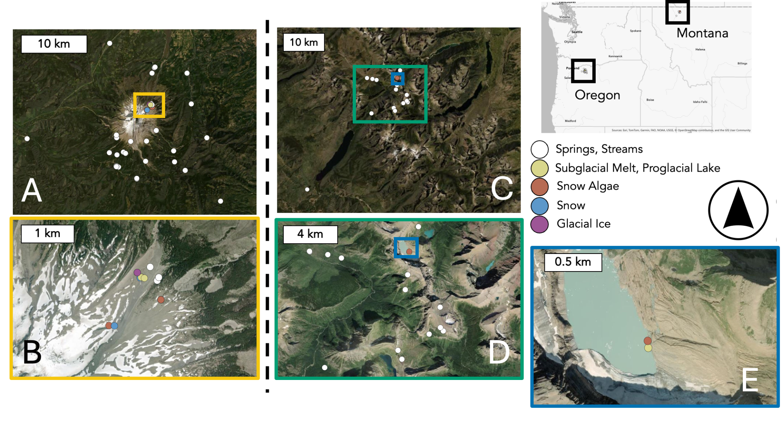

**Figure 1**. Distribution of 16S rRNA sampling sites across Mount Hood (MH; panels A, B) and Glacier National Park (GNP; panels C–E), adapted from Miller et al. (2021). Sites are colored by sample type. Inset boxes correspond to zoomed regions with matching border colors.

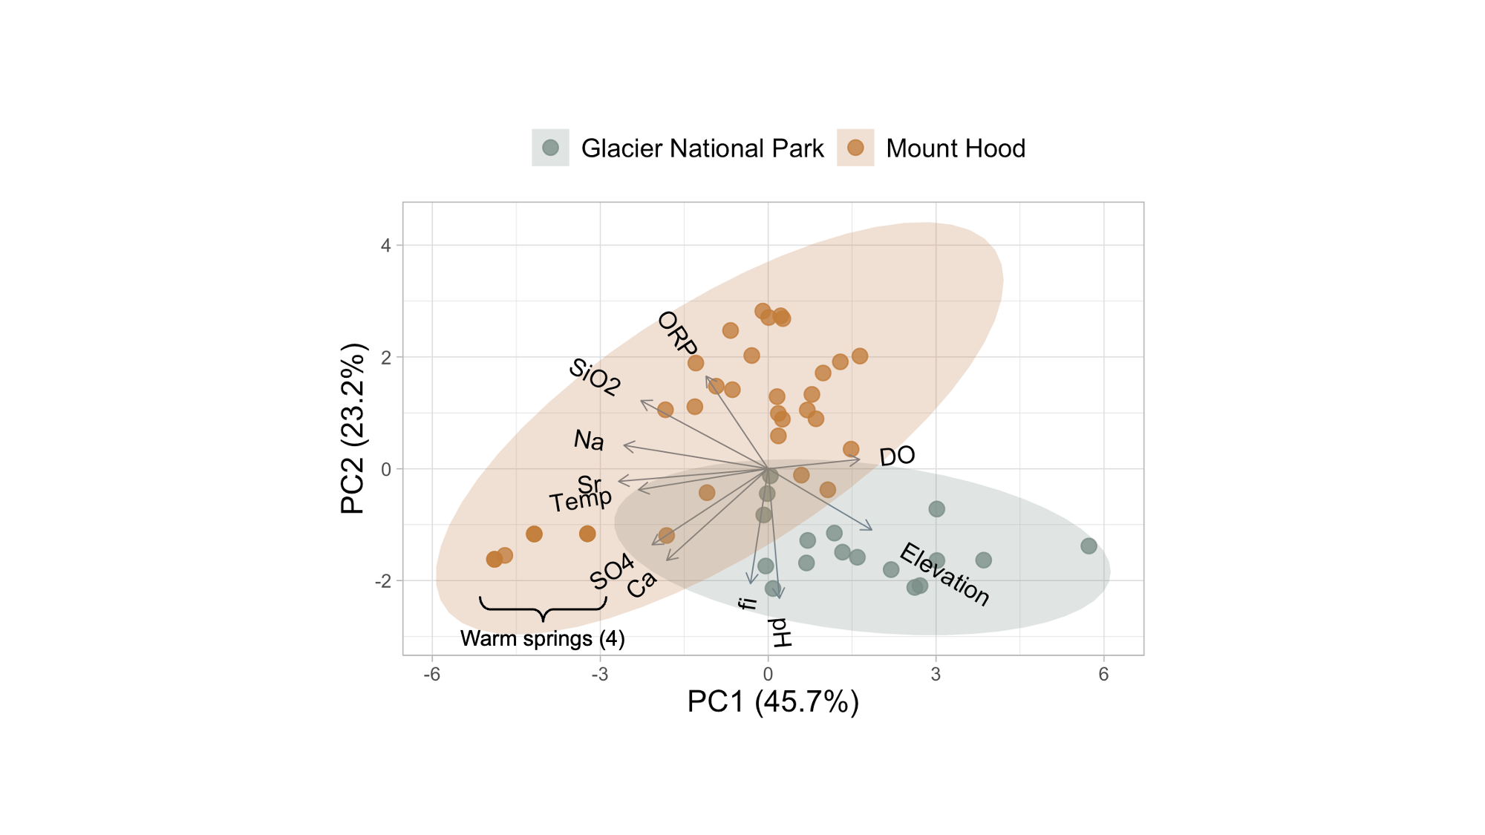

**Figure 2**. Principal components analysis (PCA) of physical and geochemical parameters across 50 spring and stream sites from Mount Hood (MH; n = 33) and Glacier National Park (GNP; n = 17). The first two components explain 68.9% of the total variance and differentiate sites at both regional (by color) and local scales. Vectors indicate the contribution of individual variables to PC1/2. Several collinear variables (e.g., HCO3-, CaCO3, SPC, Mg2+, TDS, Cl-, K+) were excluded (*see Methods*). MH’s geothermally influenced warm springs are highlighted as outliers.

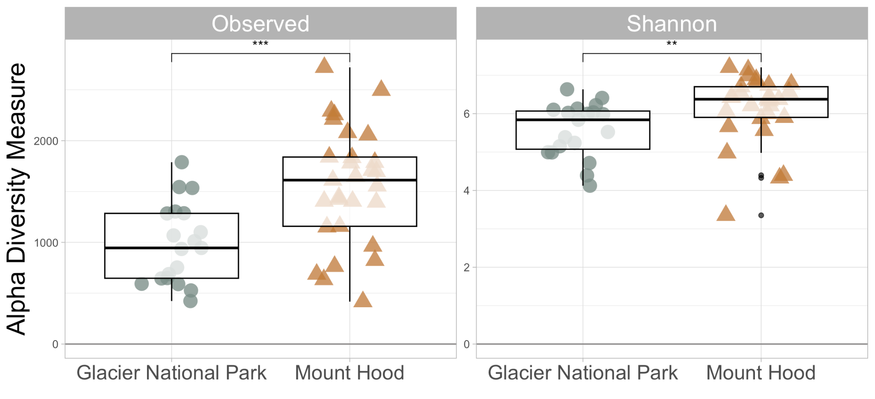

**Figure 3**. 16S alpha diversity was higher and more variable across Mount Hood sites. Richness and evenness were greater among alpine springs and streams from Mount Hood (n = 29) compared to Glacier National Park (n = 19). Black circles and lines indicate group means and 95% confidence intervals, respectively. Asterisks denote statistical significance (*** = p < 0.001, ** = p < 0.01).

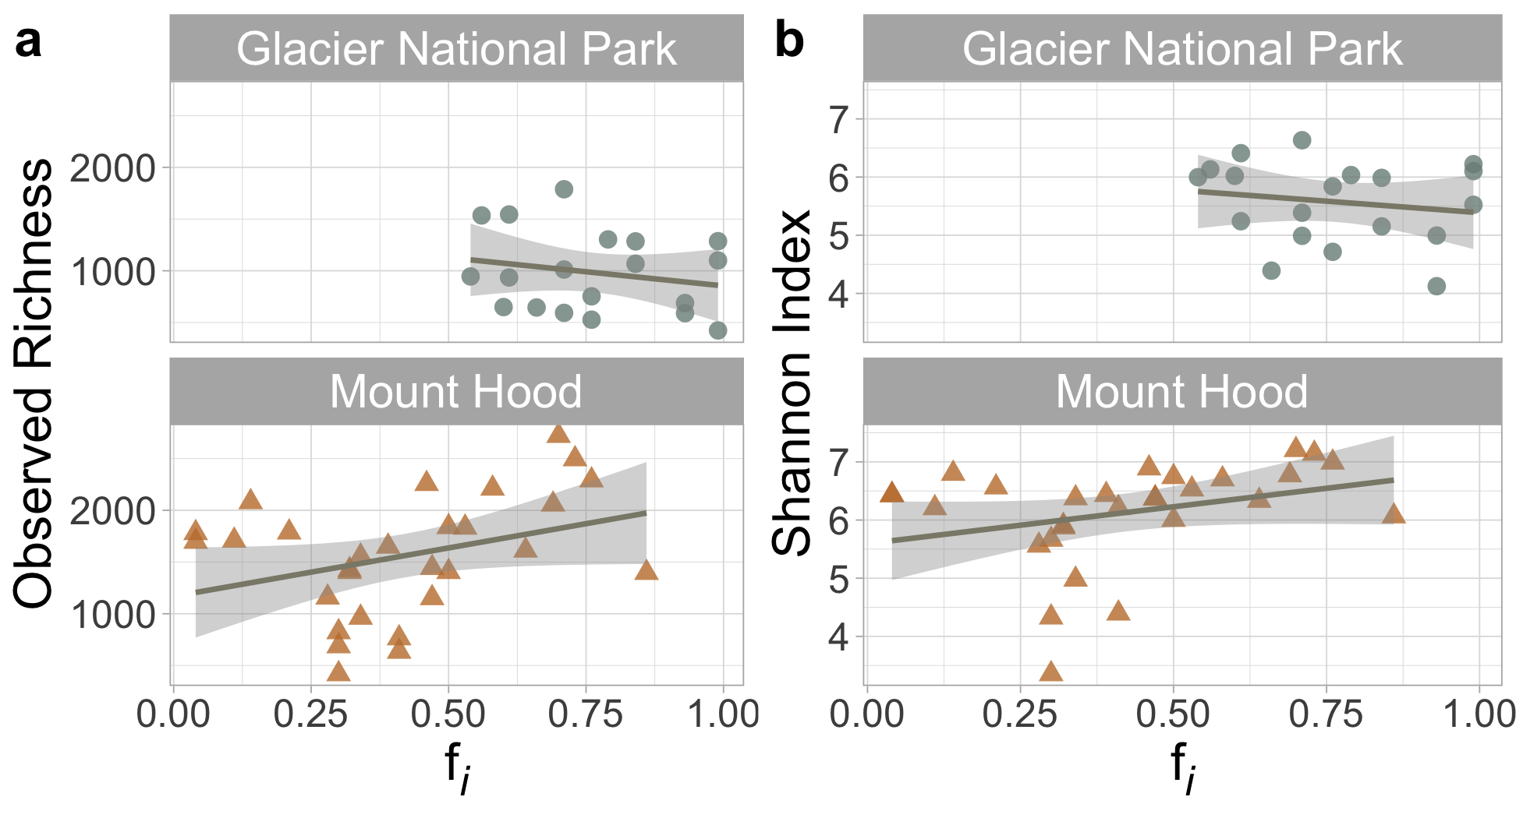

**Figure 4**. Glacier ice contributions (fi) did not significantly explain 16S alpha diversity. Plots show the relationship between the fractional contribution of glacier ice (fᵢ) and (a) richness or (b) Shannon’s diversity across springs and streams in Mount Hood (MH; n = 29) and Glacier National Park (GNP; n = 19). Weak positive and negative trends within MH and GNP, respectively, were not statistically significant (p > 0.05). Lines and shaded areas represent linear regressions and 95% confidence intervals.

**Figure 5**. Covariation (R2) of 16S community composition and selected environmental variables in MH and GNP. (filled shapes and colors). Data points are technical replicates. Empty circles and lines represent means and 95% CIs, respectively. Dotted vertical lines – colored by location – illustrate dissimilar geographic means when considering all environmental variables. 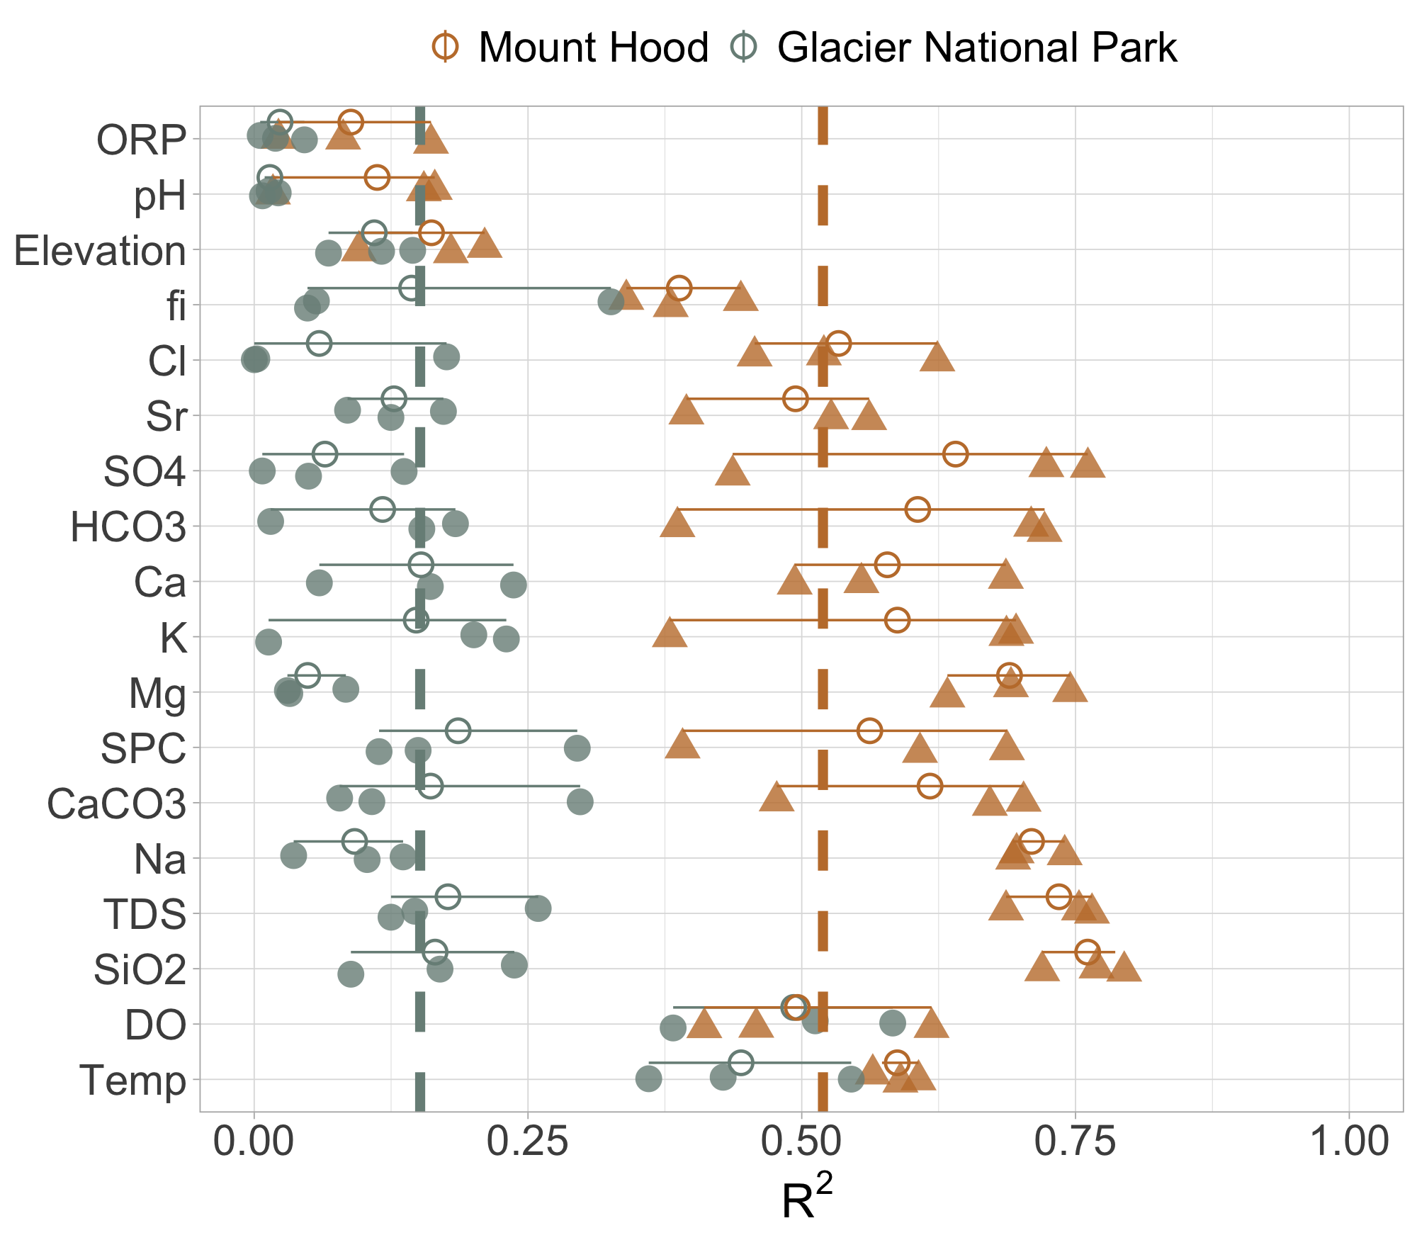

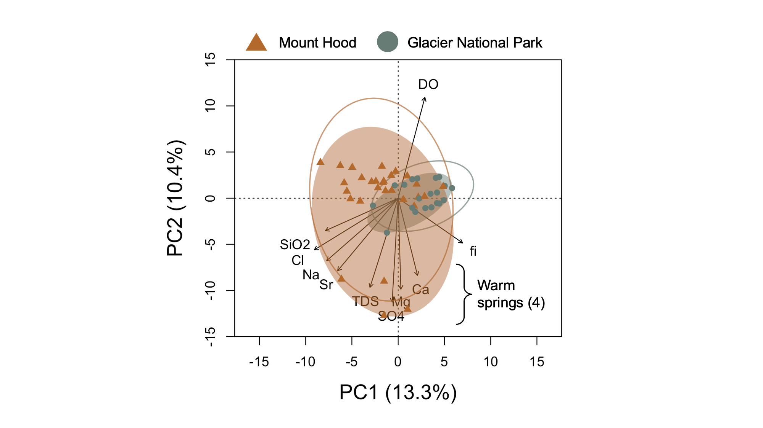

**Figure 6**. Geographic separation drives 16S beta diversity in alpine springs and streams. Principal components analysis (PCA) of bacterial communities from Mount Hood (MH) and Glacier National Park (GNP), grouped by geographic location (color and shape). The first two components explain 23.7% of the total variance. Environmental variables were fit as vectors using significant linear regressions (p < 0.05) based on their association with PC1 and PC2. Ellipses represent standard deviation within location-specific groupings.

**Figure 7**. Abundance comparison of prevalent 16S Classes in spring/stream samples where shape indicates primary recharge source (Glacier Meltwater vs. Precipitation), color sample type, and size the relative abundance as a decimal. Classes were selected if they comprised >2% of the total relative abundance of the sample. Taxa bolded are mentioned in the text (*Results*, *Discussion*).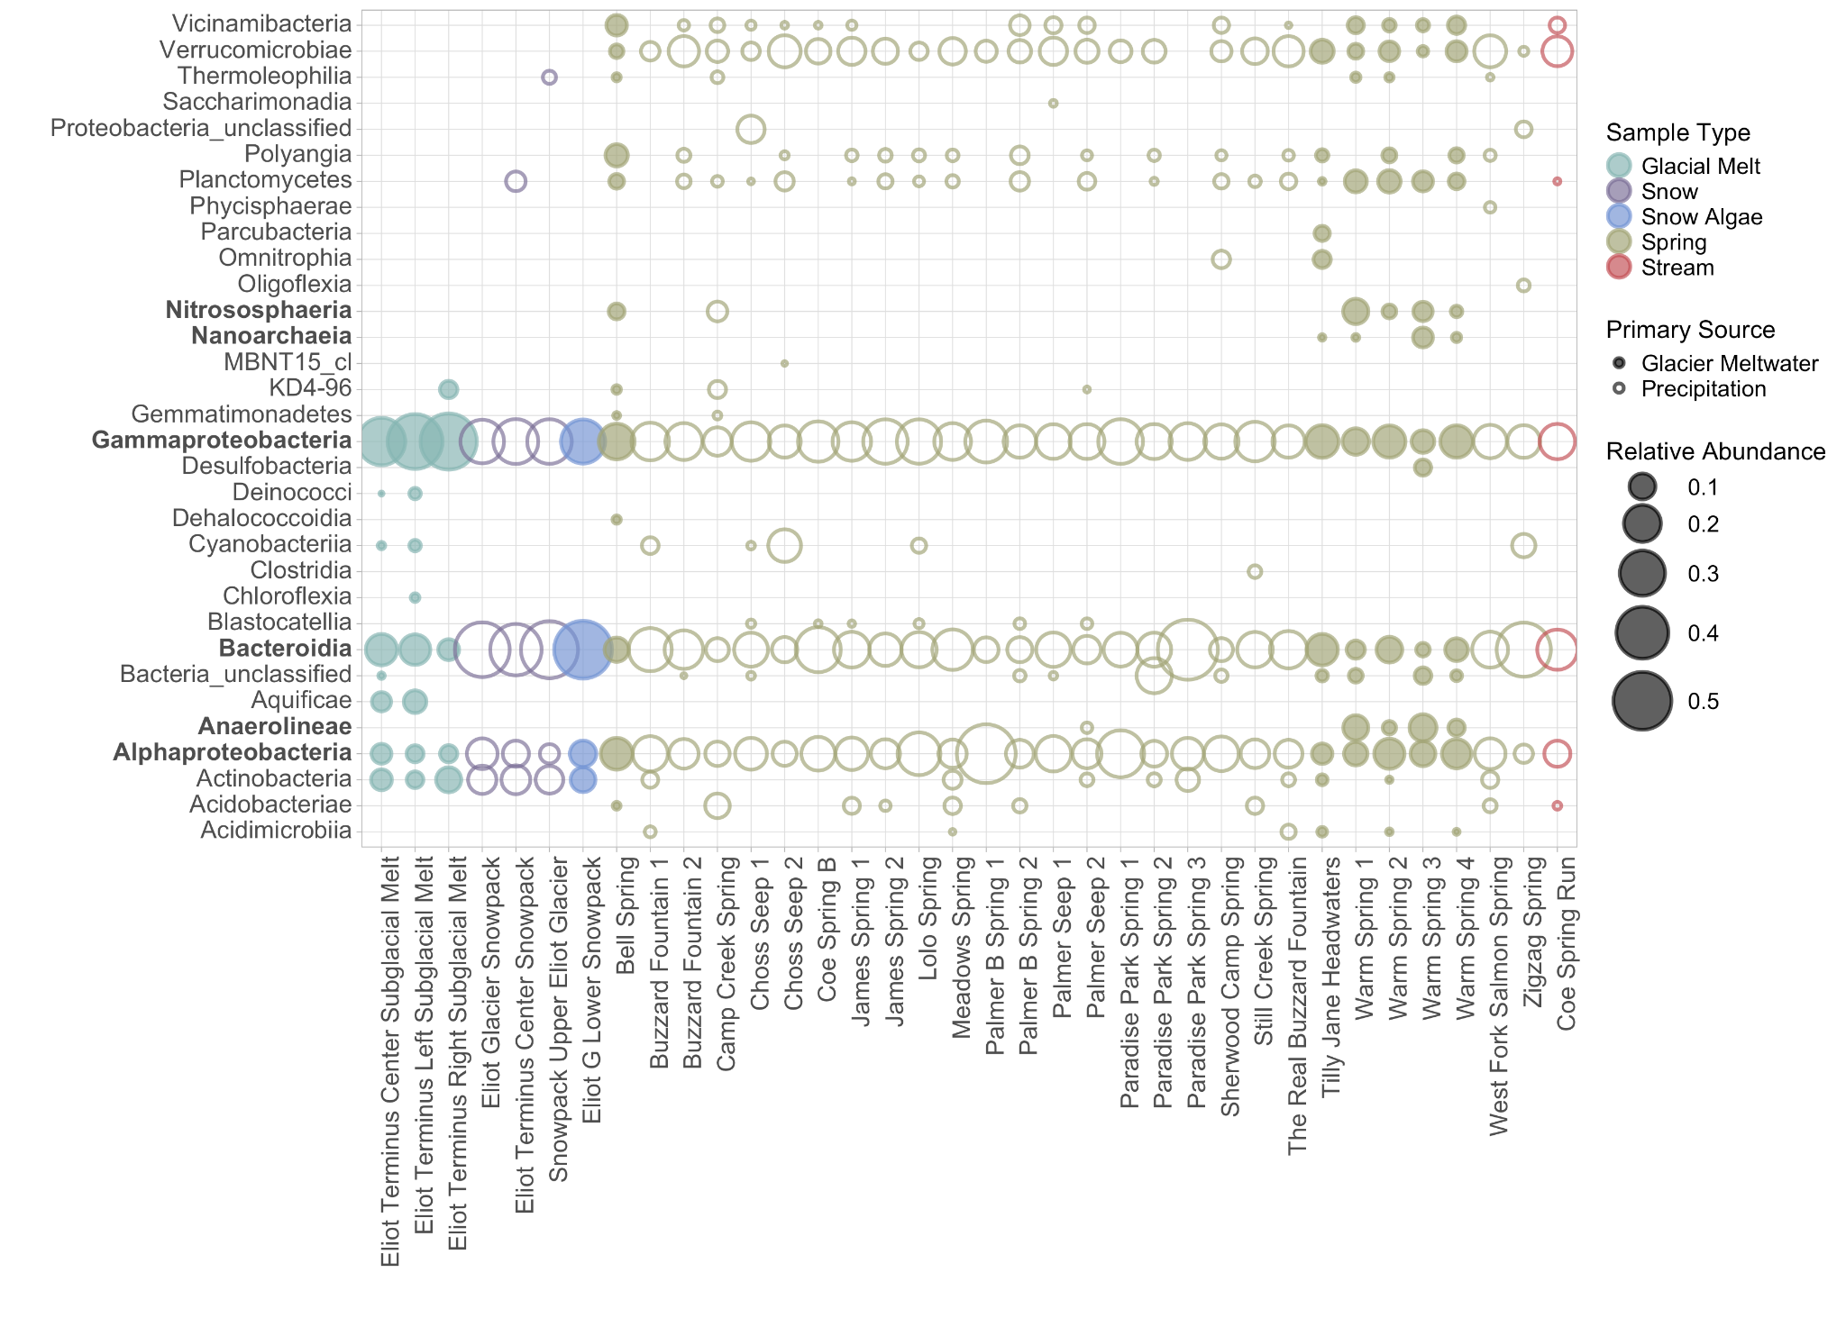

**Supporting information**

**Supplementary Table S1**. Environmental and sampling metadata, isotope mixing model outputs (e.g., fi_Best), and references to corresponding amplicon data. These data were consolidated into one sheet to streamline analyses and account for biological replicates. All data were originally collected by the authors of Miller et al. (2021) and those acknowledged in their publication.

**Supplementary Table S2**. Results of triplicate RandomForest modeling and regression analysis used to evaluate how 16S rRNA community composition covaried with 18 environmental metrics (see *2.3. Methods*) (Sperlea et al., 2021). Each model was trained using Hellinger-transformed amplicon abundances and tested using 10-fold cross-validation. Reported metrics include the coefficient of determination (Rsquared), Root Mean Squared Error (RMSE), and Mean Absolute Error (MAE) for each replicate model run. A warning notice in R indicated whether any cross-validation fold was trained using ≤ 5 unique values.

**Supplementary Table S3**. Results of triplicate RandomForest modeling and regression analysis used to evaluate how eukaryotic (18S rRNA) community composition covaried with 18 environmental metrics (see 2.3. Methods) (Sperlea et al., 2021). Each model was trained using Hellinger-transformed amplicon abundances and tested using 10-fold cross-validation. Reported metrics include the coefficient of determination (Rsquared), Root Mean Squared Error (RMSE), and Mean Absolute Error (MAE) for each replicate model run. A warning notice in R indicated whether any cross-validation fold was trained using ≤ 5 unique values. Notes show deviations from the standard pipeline due to data limitations.

**Supplementary Table S4**. Mean relative abundances of predominant 16S rRNA taxa (Phylum, Class, Order, Family, and Genus levels) across Mount Hood (MH) or Glacier National Park (GNP). Values were calculated from non-rarefied, proportionally normalized data to better reflect actual taxa prevalence. Taxa are listed in descending order of mean abundance within each Location.

**Supplementary Table S5**. Mean relative abundances of predominant 18S rRNA taxa (Phylum and Class levels) across Mount Hood (MH), Glacier National Park (GNP), and all samples combined. Values were calculated from non-rarefied, proportionally normalized data to better reflect actual taxa prevalence. Taxa are listed in descending order of mean abundance within each Location.

**Supplementary Table S6**. Mean Bray-Curtis dissimilarities among biological replicates of 16S rRNA communities at spring/stream sites with multiple replicates. Sites include both locations: Mount Hood and Glacier National Park. Values reflect pairwise distances between replicates. See *2.3.1 Methods* and Figure S5 for context. Replicates were treated as independent in downstream analyses.

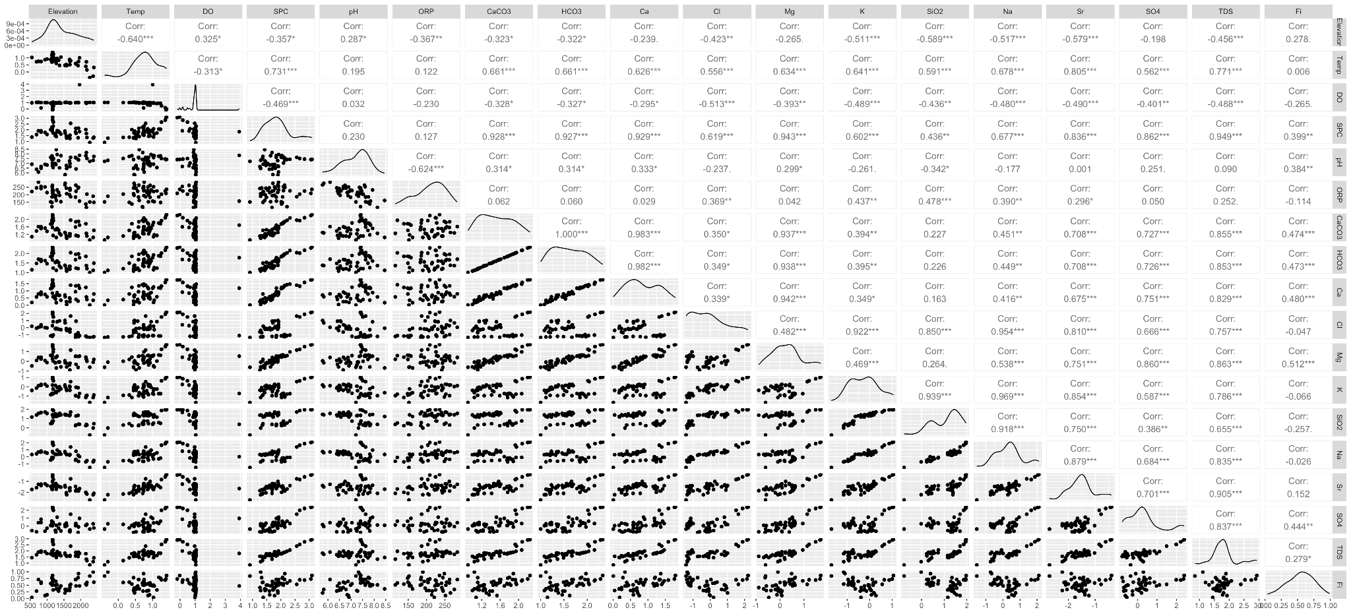

**Figure S1**. **Pairwise correlations and distributions of hydrogeochemical variables used in our abiotic PCA, after log**₁₀**(x+1) transformation**. The Upper triangle shows Pearson correlation coefficients (r). Lower triangle shows scatterplots presenting cross-variable interactions. Variables exhibiting strong collinearity (r > 0.9, highlighted in red) qualified for removal. Diagonal histograms show near-normal distributions, reflecting log10-transformation. This analysis informed variable selection to minimize multicollinearity while supporting biogeochemical interpretations (see *Methods*).

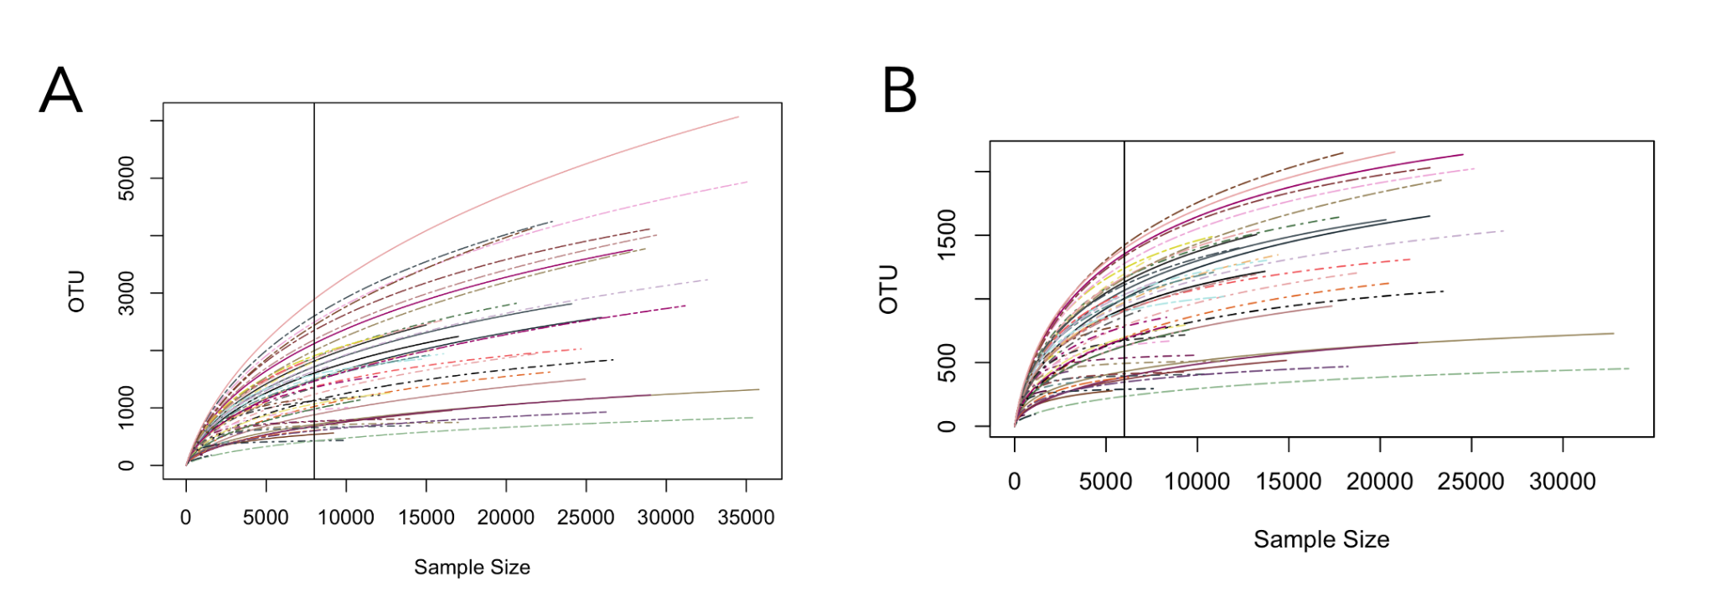

**Figure S2.** Rarefaction curve for alpha diversity analyses (**A** = 16S dataset; **B** = 18S dataset). Abline = Subsampling read depth.

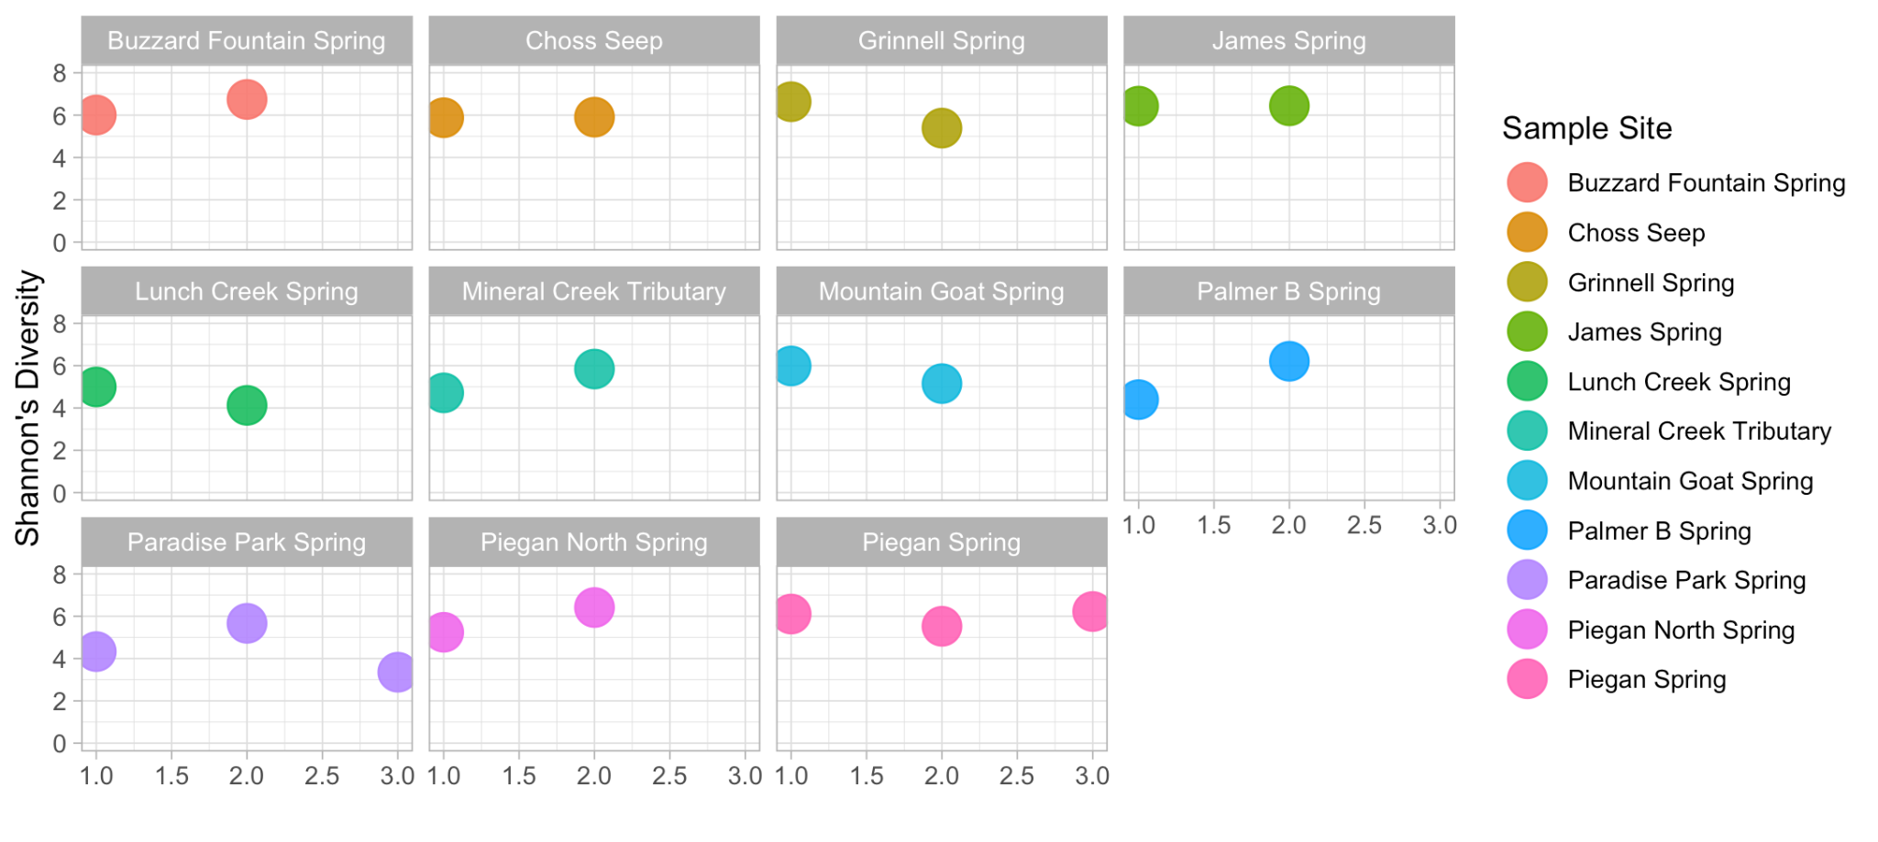

**Figure S3**. Variability in *Shannon’s diversity* between biological replicates (16S rRNA dataset). X-axis = Replicate # (1-3).

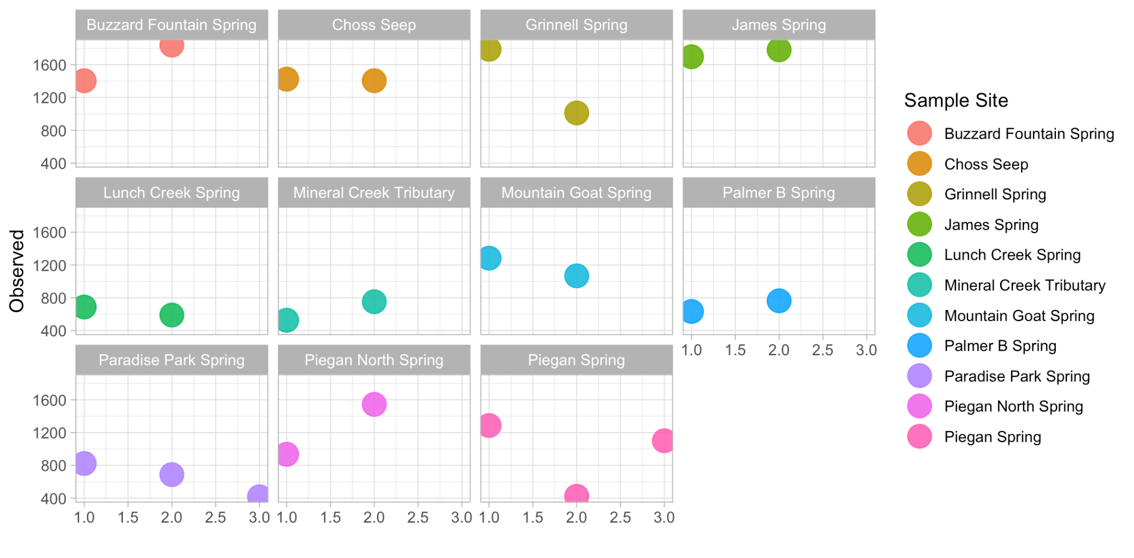

**Figure S4**. Variability in *Observed richness* between biological replicates (16S rRNA dataset). X-axis = Replicate # (1-3).

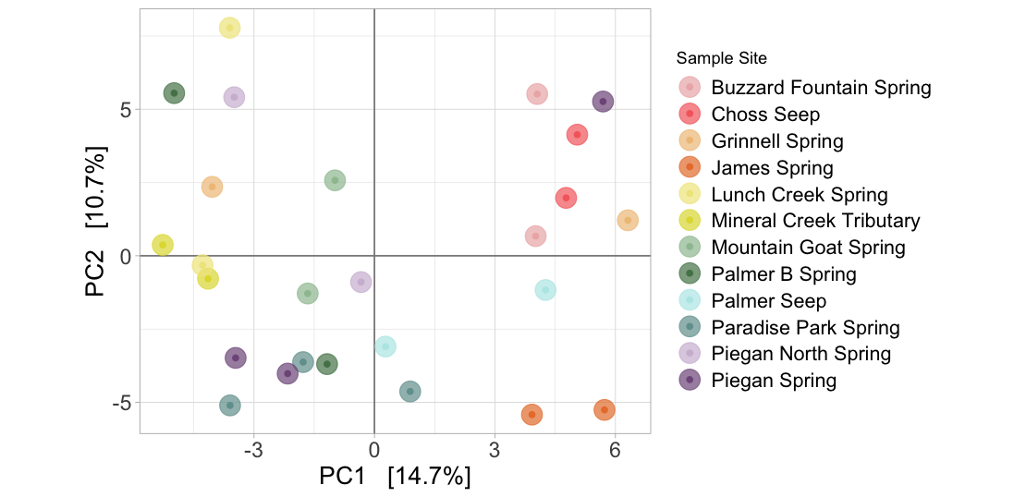

**Figure S5**. PCA demonstrating variability between **biological replicates** (16S rRNA dataset).

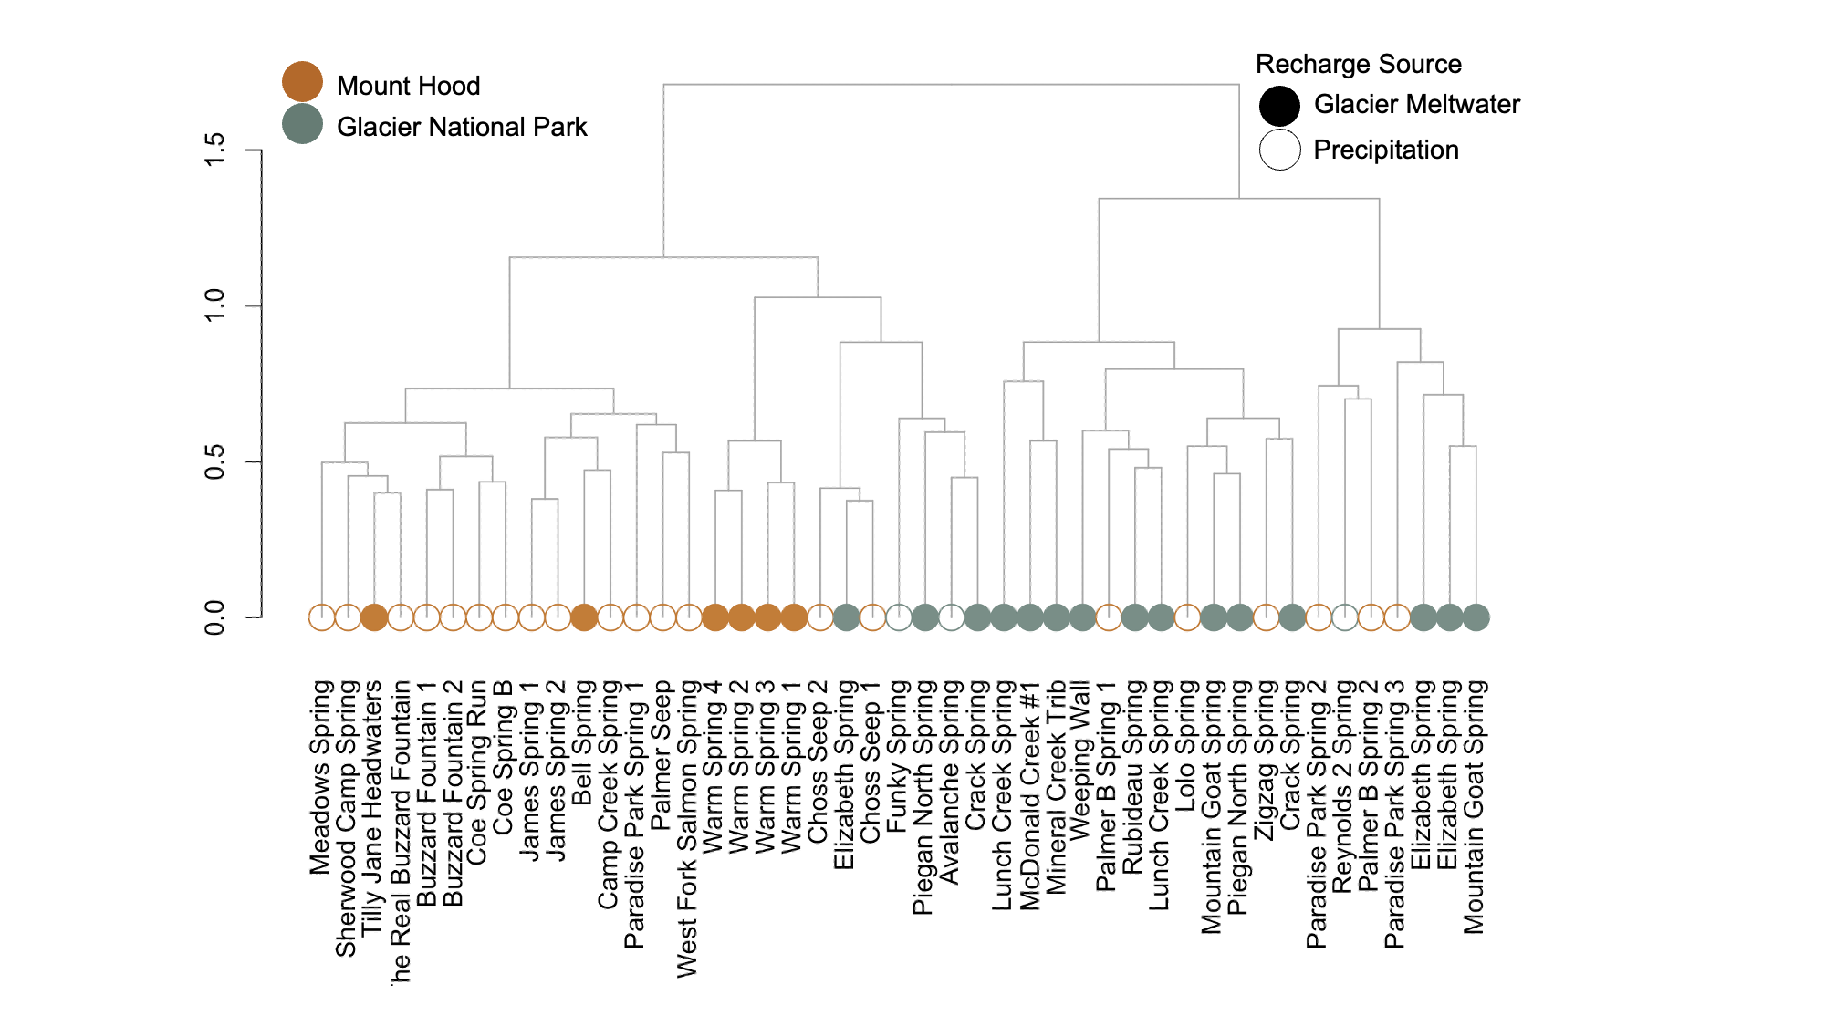

**Figure S6**. Hierarchical clustering of sample communities per *Bray-Curtis dissimilarity*. Y-axis = Level of variability at each branch-point. 16S rRNA dataset.

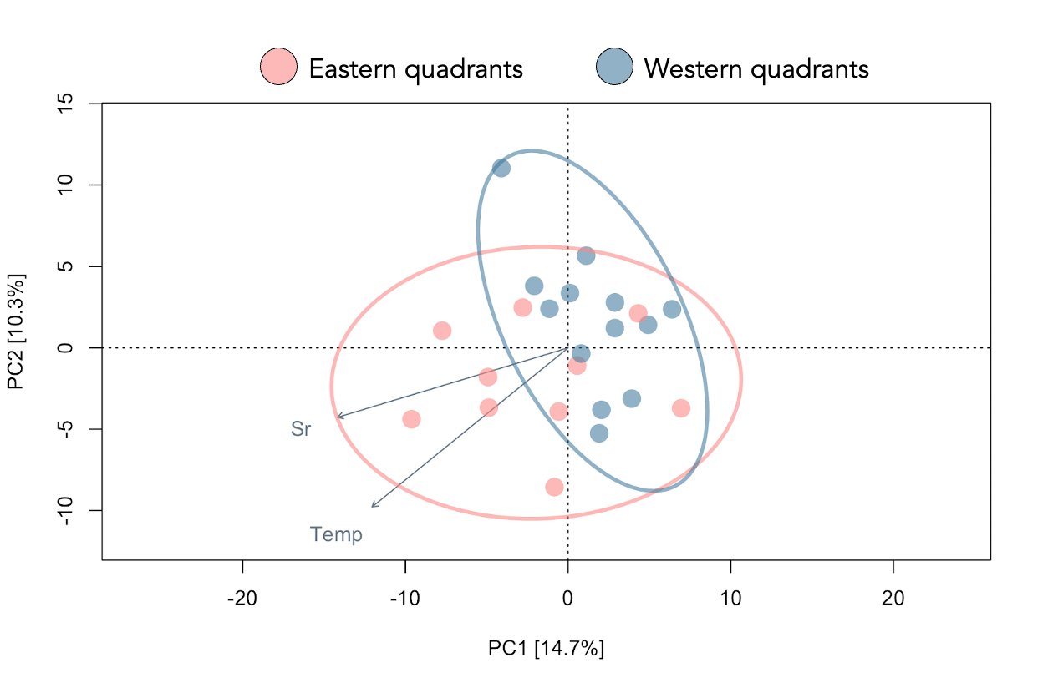

**Figure S7**. Principal component analysis (PCA) of spring and stream microbiome samples from MH grouped by ester- and western-facing quadrant without including warm springs. The top two components explained 25.0% of the total variation. Like Figure 6, Fitted environmental variables represent significant linear regressions (p<0.05) between PC1/PC2 and physicochemical measurements. Ellipses show the standard deviation within each quadrant group.

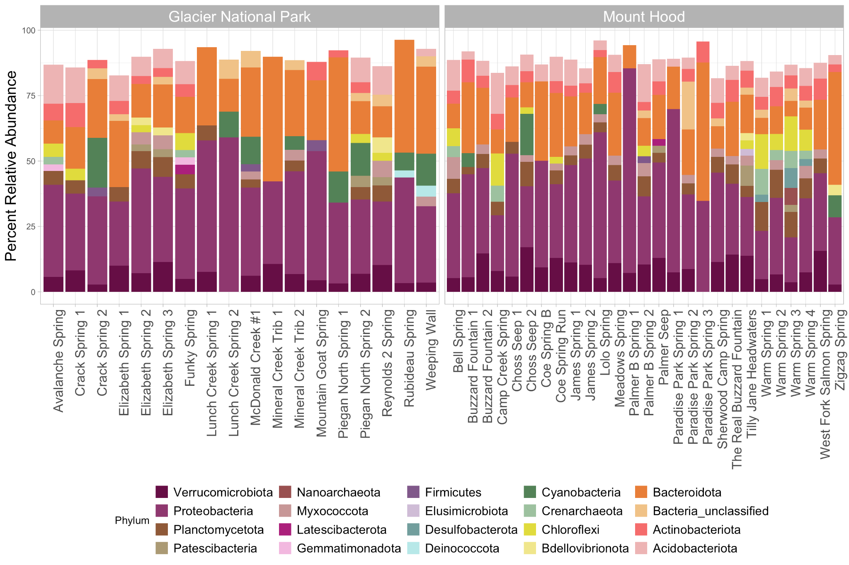

**Figure S8**. 16S Phyla relative abundance plot using rarefied alpha diversity dataset. Phyla containing < 2% relative abundance in each sample were removed.

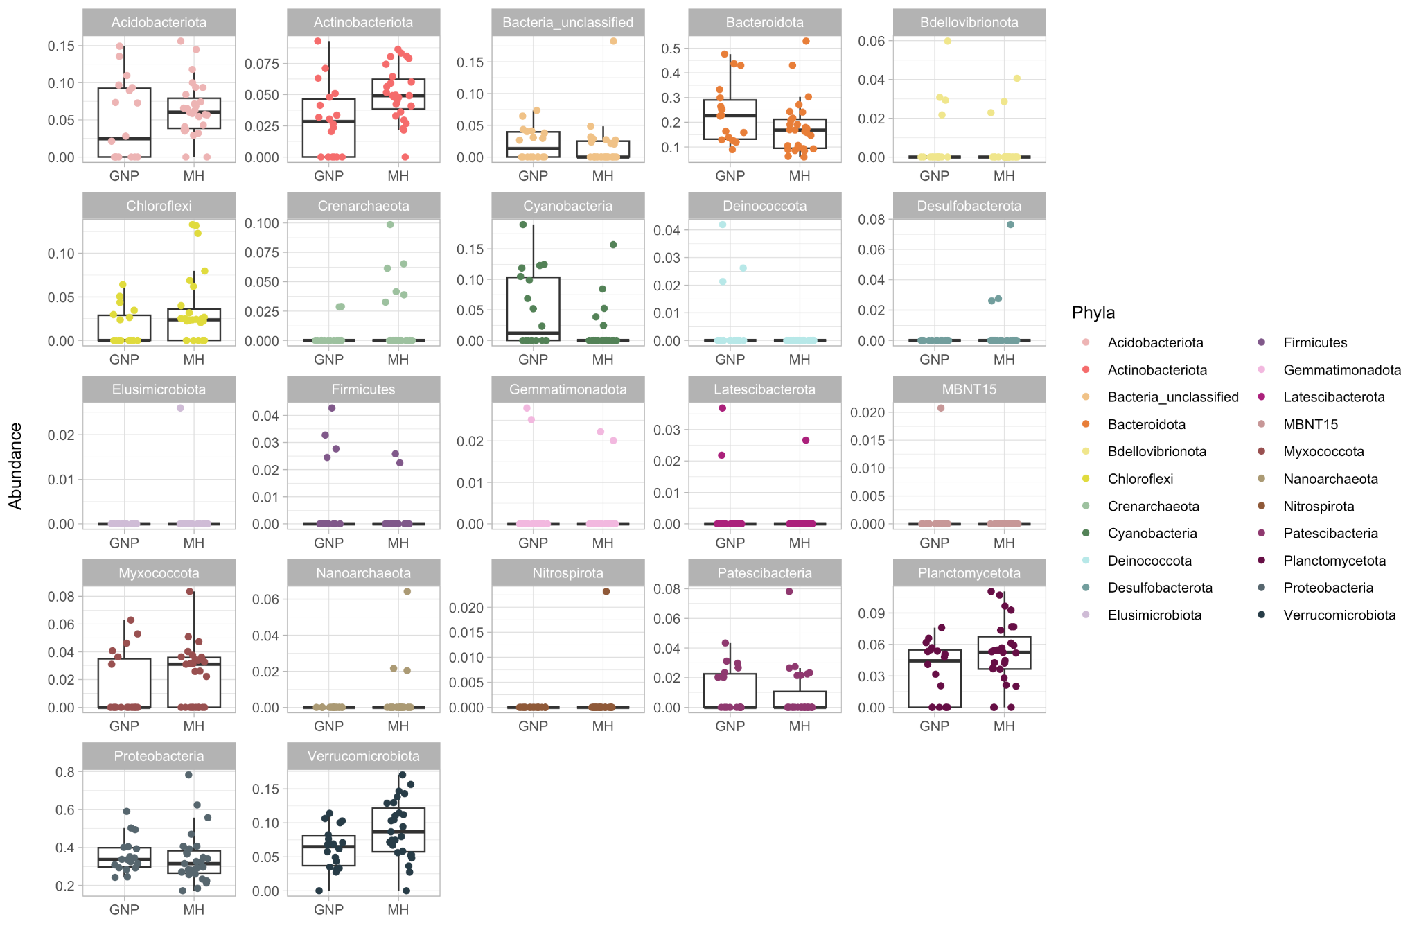

**Figure S9**. Differences in relative 16S phyla abundance by location (Glacier National Park = GNP; Mount Hood = MH)

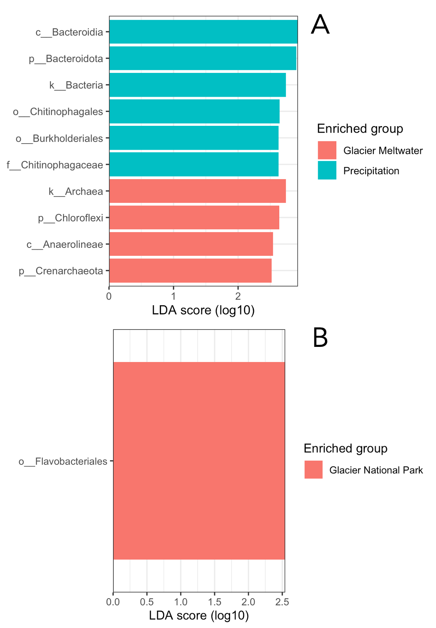

**Figure S10**. 16S bioindator taxa identified via LEfSe analysis of sourcing in MH (a) and between glacier systems (b).

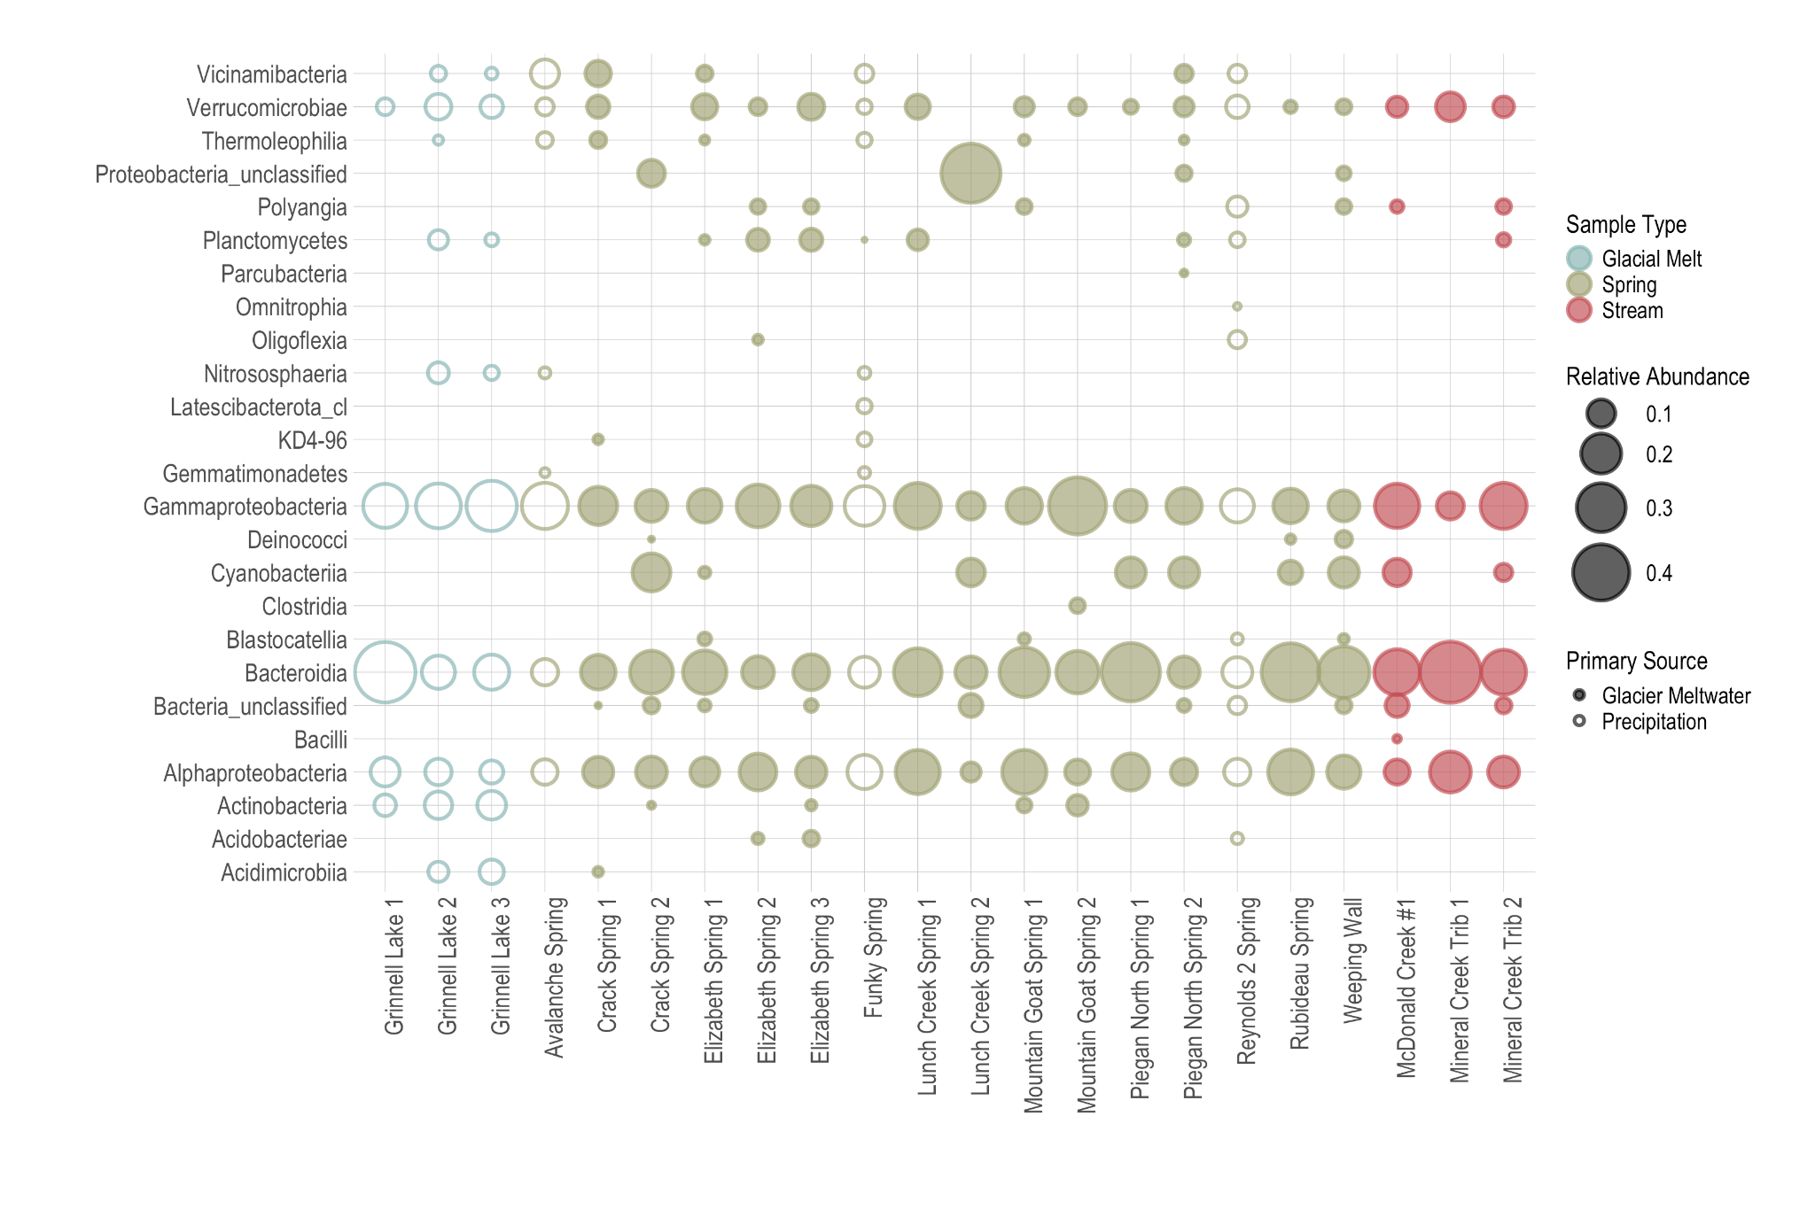

**Figure S11**. The relative abundance of GNP 16S Classes varies between sample types (e.g., Springs/Streams vs. End-Members).

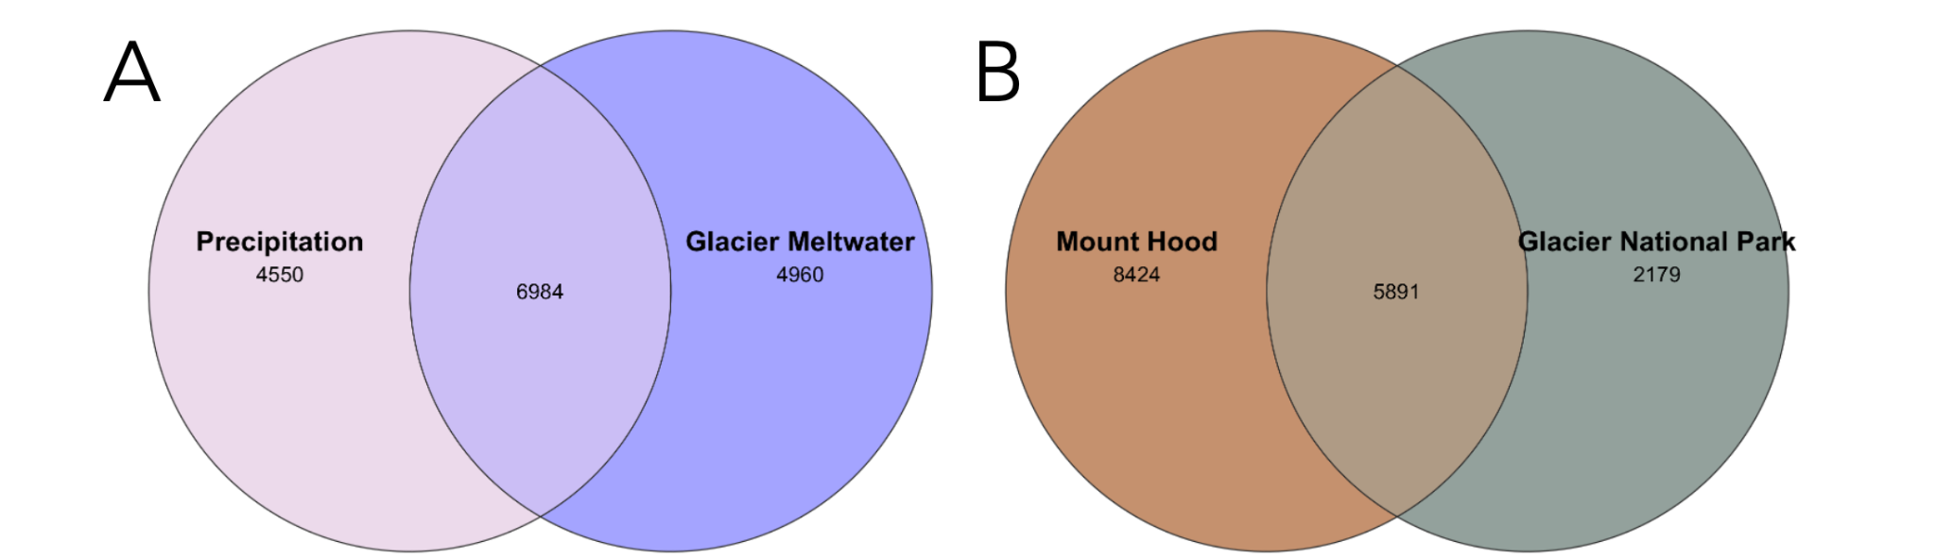

**Figure S12**. Shared and unshared 16S taxa across (**A**) primary recharge sources, and (**B**) locations. Unrarefied dataset.

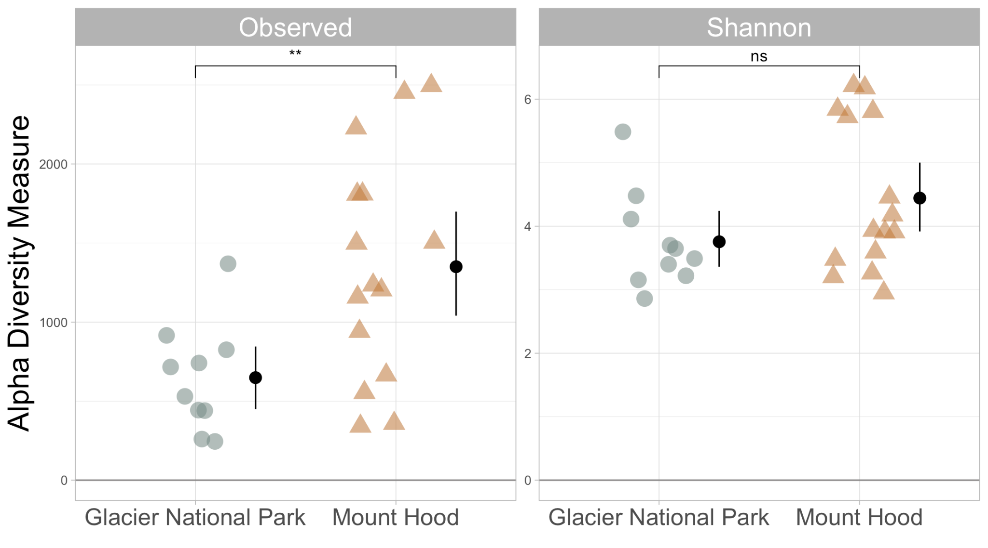

**Figure S13**. 18S alpha diversity was higher and more variable across Mount Hood sites. Observed richness was greater among alpine springs and streams from Mount Hood (n = 10) compared to Glacier National Park (n = 5). Black circles and lines indicate group means and 95% confidence intervals, respectively. Asterisks denote statistical significance (** = p < 0.01).

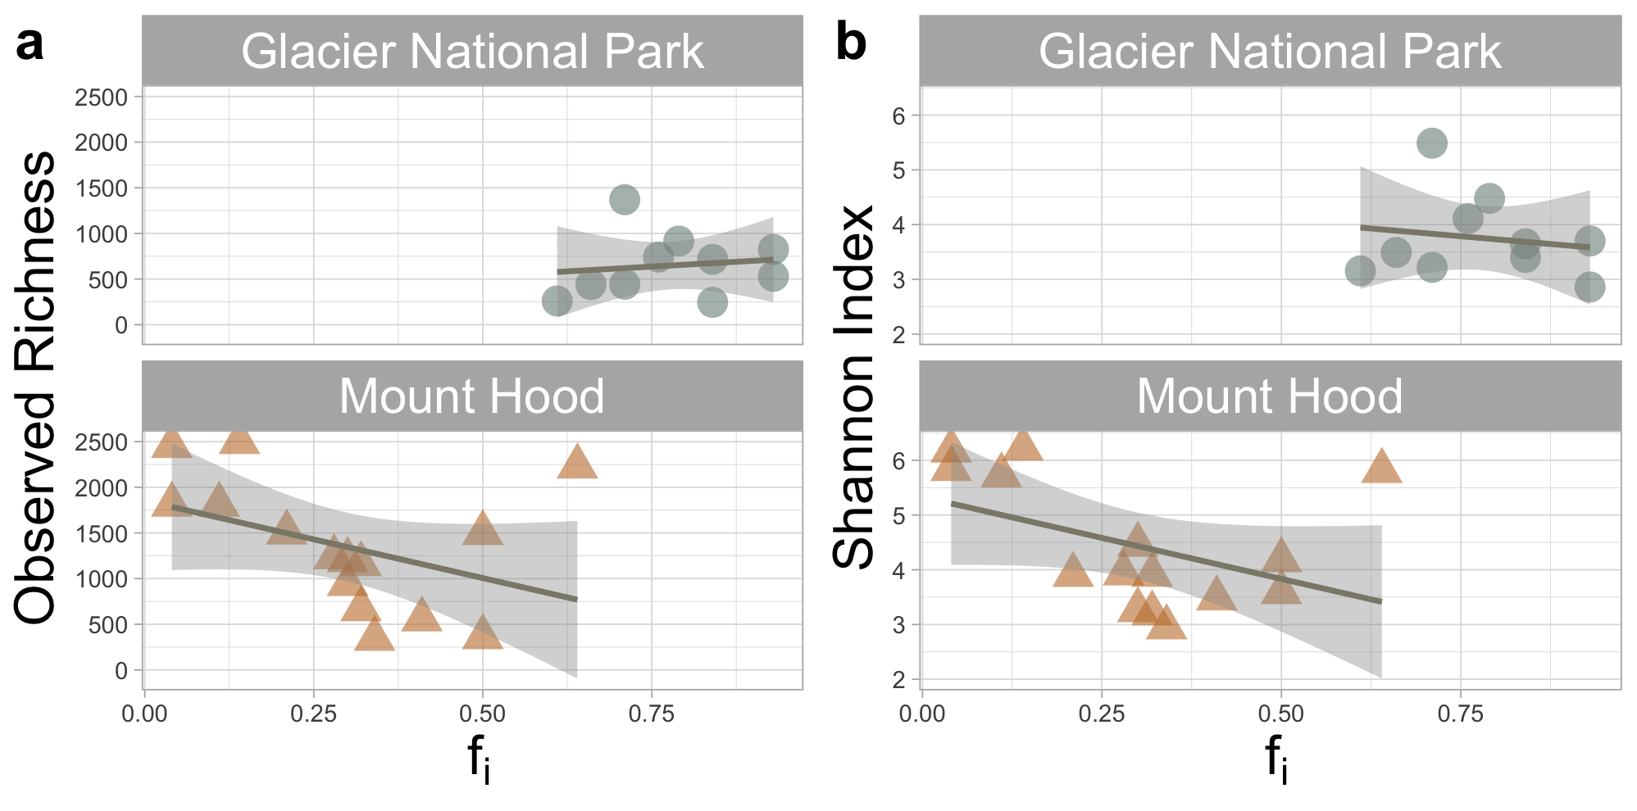

**Figure S14**. Glacier ice contributions (fi) did not significantly explain 18S alpha diversity. Plots show the relationship between the fractional contribution of glacier ice (fᵢ) and (a) richness or (b) Shannon’s diversity across springs and streams in Mount Hood (MH; n = 10) and Glacier National Park (GNP; n = 5). Weak positive and negative trends within MH and GNP, respectively, were not statistically significant (p > 0.05). Lines and shaded areas represent linear regressions and 95% confidence intervals.

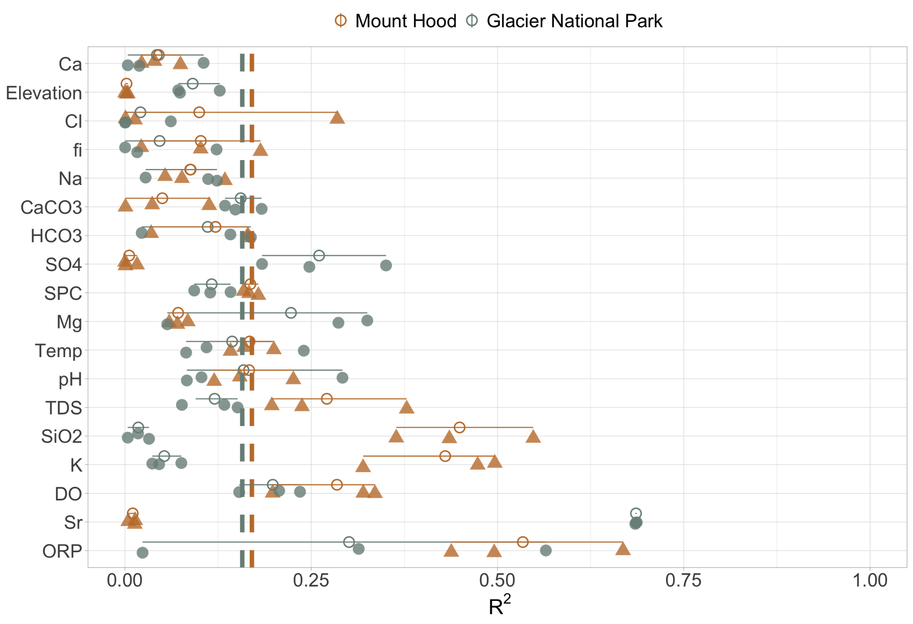

**Figure S15**. Covariation (R2) of 18S community composition and selected environmental variables in MH and GNP. (filled shapes and colors). Data points are technical replicates. Empty circles and lines represent means and 95% CIs, respectively. Dotted vertical lines – colored by location – illustrate dissimilar geographic means when considering all environmental variables.

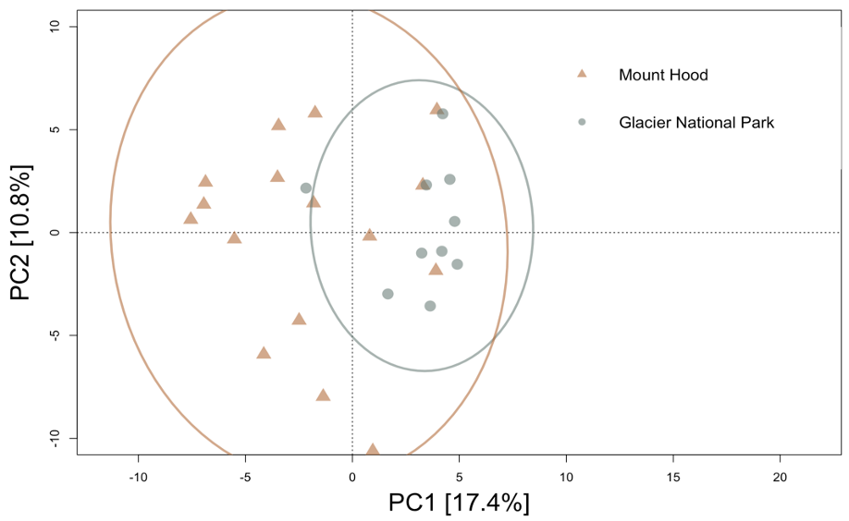

**Figure S16**. Geographic separation drives 18S beta diversity in alpine springs and streams. Principal components analysis (PCA) of bacterial communities from Mount Hood (MH) and Glacier National Park (GNP), grouped by geographic location (color and shape). The first two components explain 28.2% of the total variance. No environmental variables significantly correlated with ordination space (p > 0.05). Ellipses represent standard deviation within location-specific groupings.

**References**

Immerzeel, W. W., Lutz, A. F., Andrade, M., Bahl, A., Biemans, H., Bolch, T., Hyde, S., Brumby, S., Davies, B. J., Elmore, A. C., Emmer, A., Feng, M., Fernández, A., Haritashya, U., Kargel, J. S., Koppes, M., Kraaijenbrink, P. D. A., Kulkarni, A. V., Mayewski, P. A., … Baillie, J. E. M. (2020). Importance and vulnerability of the world’s water towers. *Nature (London), 577*(7790), 364–369.<https://doi.org/10.1038/s41586-019-1822-y>

Losapio, G., Lee, J. R., Fraser, C. I., Gillespie, M. A. K., Kerr, N. R., Zawierucha, K., Hamilton, T. L., Hotaling, S., Kaufmann, R., Kim, O.-S., Klopsch, C., Liu, Y., Lukashanets, D., Robinson, S. A., & Brown, L. E. (2025). Impacts of deglaciation on biodiversity and ecosystem function. *Nature Reviews Biodiversity*.<https://doi.org/10.1038/s44358-025-00049-6>

Miller, J. B., Frisbee, M. D., Hamilton, T. L., & Murugapiran, S. K. (2021). Recharge from glacial meltwater is critical for alpine springs and their microbiomes. *Environmental Research Letters, 16*(6), 64012-.<https://doi.org/10.1088/1748-9326/abf06b>

van Tiel, M., Aubry-Wake, C., Somers, L., Andermann, C., Avanzi, F., Baraer, M., Chiogna, G., Daigre, C., Das, S., Drenkhan, F., Farinotti, D., Fyffe, C. L., de Graaf, I., Hanus, S., Immerzeel, W., Koch, F., McKenzie, J. M., Müller, T., Popp, A. L., … Yapiyev, V. (2024). Cryosphere–groundwater connectivity is a missing link in the mountain water cycle. *Nature Water, 2*(7), 624–637.<https://doi.org/10.1038/s44221-024-00277-8>

Cook, S. J., Jouvet, G., Millan, R., Rabatel, A., Zekollari, H., & Dussaillant, I. (2023). Committed Ice Loss in the European Alps Until 2050 Using a Deep‐Learning‐Aided 3D Ice‐Flow Model With Data Assimilation. *Geophysical Research Letters, 50*(23).<https://doi.org/10.1029/2023GL105029>

IPCC. IPCC Special Report on the Ocean and Cryosphere in a Changing Climate

(Cambridge Univ. Press, 2019).

Baraer, M., McKenzie, J., Mark, B. G., Gordon, R., Bury, J., Condom, T., Gomez, J., Knox, S., & Fortner, S. K. (2015). Contribution of groundwater to the outflow from ungauged glacierized catchments; a multi-site study in the tropical Cordillera Blanca, Peru. *Hydrological Processes, 29*(11), 2561–2581.<https://doi.org/10.1002/hyp.10386>

Tolley, D. G., Frisbee, M. D., Campbell, A. R., Petronis, M. S., Lindline, J., & Zebrowski, J. (2015). Determining the importance of seasonality on groundwater recharge and streamflow in the Sangre de Cristo Mountains using stable isotopes. Guidebook - New Mexico *Geological Society, 66*, 303–312

Wagner, T., Kainz, S., Krainer, K., & Winkler, G. (2021). Storage‐discharge characteristics of an active rock glacier catchment in the Innere Ölgrube, Austrian Alps. *Hydrological Processes, 35*(5).<https://doi.org/10.1002/hyp.14210>

Wanner, P., Zischg, A., & Wanner, C. (2023). Quantifying the glacial meltwater contribution to mountainous streams using stable water isotopes: What are the opportunities and limitations? *Hydrological Processes, 37*(9).<https://doi.org/10.1002/hyp.14963>

Beria, H., Larsen, J. R., Ceperley, N. C., Michelon, A., Vennemann, T., & Schaefli, B. (2018). Understanding snow hydrological processes through the lens of stable water isotopes. Wiley Interdisciplinary Reviews. *Water, 5*(6), 1-n/a.<https://doi.org/10.1002/wat2.1311>

Sugiyama, A., Masuda, S., Nagaosa, K., Tsujimura, M., & Kato, K. (2018). Tracking the direct impact of rainfall on groundwater at Mt. Fuji by multiple analyses including microbial DNA. *Biogeosciences, 15*(3), 721–732.<https://doi.org/10.5194/bg-15-721-2018>

URycki, D. R., Bassiouni, M., Good, S. P., Crump, B. C., & Li, B. (2022). The streamwater microbiome encodes hydrologic data across scales. *The Science of the Total Environment, 849*, 157911–157911.<https://doi.org/10.1016/j.scitotenv.2022.157911>

Varliero, G., Lebre, P. H., Frey, B., Fountain, A. G., Anesio, A. M., & Cowan, D. A. (2023). Glacial Water: A Dynamic Microbial Medium. *Microorganisms (Basel), 11*(5), 1153-.<https://doi.org/10.3390/microorganisms11051153>

Boyd, E. S., Lange, R. K., Mitchell, A. C., Havig, J. R., Hamilton, T. L., Lafreniere, M. J., Shock, E. L., Peters, J. W., Skidmore, M. (2011). Diversity, Abundance, and Potential Activity of Nitrifying and Nitrate-Reducing Microbial Assemblages in a Subglacial Ecosystem. *Applied and Environmental Microbiology*, *77*(14), 4778–4787.<https://doi.org/10.1128/AEM.00376-11>

Crosta, A., Valle, B., Caccianiga, M., Gobbi, M., Ficetola, F. G., Pittino, F., Franzetti, A., Azzoni, R. S., Lencioni, V., Senese, A., Corlatti, L., Buda, J., Poniecka, E., Novotná Jaroměřská, T., Zawierucha, K., & Ambrosini, R. (2025). Ecological interactions in glacier environments: a review of studies on a model Alpine glacier. *Biological Reviews of the Cambridge Philosophical Society, 100*(1), 227–244.<https://doi.org/10.1111/brv.13138>

Dunham, E. C., Dore, J. E., Skidmore, M. L., Roden, E. E., Boyd, E. S. (2021). Lithogenic hydrogen supports microbial primary production in subglacial and proglacial environments. *Proceedings of the National Academy of Sciences - PNAS*, *118*(2).<https://doi.org/10.1073/pnas.2007051117>

Havig, J. R., & Hamilton, T. L. (2019). Snow algae drive productivity and weathering at volcanic rock-hosted glaciers. *Geochimica et Cosmochimica Acta, 247*, 220–242.<https://doi.org/10.1016/j.gca.2018.12.024>

Lamarche-Gagnon, G., Wadham, J. L., Sherwood Lollar, B., Arndt, S., Fietzek, P., Beaton, A. D., Tedstone, A. J., Telling, J., Bagshaw, E. A., Hawkings, J. R., Kohler, T. J., Zarsky, J. D., Mowlem, M. C., Anesio, A. M., Stibal, M. (2019). Greenland melt drives continuous export of methane from the ice-sheet bed. *Nature (London)*, *565*(7737), 73–77.<https://doi.org/10.1038/s41586-018-0800-0>

Kohler, T., Fodelianakis, S., Michoud, G., Ezzat, L., Bourquin, M., Peter, H., . . . Battin, T. (2022). Glacier shrinkage will accelerate downstream decomposition of organic matter and alters microbiome structure and function. Global Change Biology, Global change biology, 2022-03-23.

Milner, A., Khamis, K., Battin, T., Brittain, J., Barrand, N., Füreder, L., . . . Brown, L. (2017). Glacier shrinkage driving global changes in downstream systems. Proceedings of the National Academy of Sciences - PNAS, 114(37), 9770-9778.

R Core Team (2025). R: A language and environment for statistical computing. R Foundation for Statistical Computing, Vienna, Austria. v4.5.0. [https://www.R-project.org/](https://www.r-project.org/)

McMurdie, P., Holmes, S. (2013). Phyloseq: An R package for reproducible interactive analysis and graphics of microbiome census data. PloS One, 8(4), E61217.

Sauer, H. M., Hamilton, T. L., Anderson, R. E., Umbanhowar, C. E., & Heathcote, A. J. (2022). Diversity and distribution of sediment bacteria across an ecological and trophic gradient. *PloS One, 17*(3), e0258079–e0258079.<https://doi.org/10.1371/journal.pone.0258079>

Vu, V. Q. (2011). ggbiplot: A ggplot2 Based Biplot. R Package Version 0.55. Available online at:<http://github.com/vqv/ggbiplot> (accessed April 13, 2025).

Fields, J. F., & Dethier, D. P. (2019). From on high; geochemistry of alpine springs, Niwot Ridge, Colorado Front Range, USA. *Hydrological Processes, 33*(12), 1756–1774.<https://doi.org/10.1002/hyp.13436>

Ghezzi, D., Foschi, L., Firrincieli, A., Hong, P.-Y., Vergara, F., De Waele, J., Sauro, F., & Cappelletti, M. (2022). Insights into the microbial life in silica-rich subterranean environments: microbial communities and ecological interactions in an orthoquartzite cave (Imawari Yeuta, Auyan Tepui, Venezuela). *Frontiers in Microbiology*, 13, 930302–930302.<https://doi.org/10.3389/fmicb.2022.930302>

Oksanen, J., Blanchet, F. G., Friendly, M., Kindt, R., Legendre, P., McGlinn, D., Minchin, P. R., O'Hara, R. B., Simpson, G. L., Solymos, P., Stevens, M. H. H., Szoecs, E., & Wagner, H. (2018). vegan: Community Ecology Package. CRAN [R package version 2.5-2]

Schloss, P. D., & McMahon, K. (2024). Rarefaction is currently the best approach to control for uneven sequencing effort in amplicon sequence analyses. *mSphere, 9*(2), e0035423–e0035423.<https://doi.org/10.1128/msphere.00354-23>

Sperlea, T., Kreuder, N., Beisser, D., Hattab, G., Boenigk, J., & Heider, D. (2021). Quantification of the covariation of lake microbiomes and environmental variables using a machine learning‐based framework. *Molecular Ecology, 30*(9), 2131–2144.<https://doi.org/10.1111/mec.1587>2

Segata, N., Izard, J., Waldron, L., Gevers, D., Miropolsky, L., Garrett, W. S., & Huttenhower, C. (2011). Metagenomic biomarker discovery and explanation. *Genome Biology, 12*(6), R60–R60.<https://doi.org/10.1186/gb-2011-12-6-r60>

Nearing, J. T., Douglas, G. M., Hayes, M. G., MacDonald, J., Desai, D. K., Allward, N., Jones, C. M. A., Wright, R. J., Dhanani, A. S., Comeau, A. M., & Langille, M. G. I. (2022). Microbiome differential abundance methods produce different results across 38 datasets. *Nature Communications, 13*(1), 342–342.<https://doi.org/10.1038/s41467-022-28034-z>

Guo, X., Yan, Q., Wang, F., Wang, W., Zhang, Z., Liu, Y., & Liu, K. (2024). Habitat-specific patterns of bacterial communities in a glacier-fed lake on the Tibetan Plateau. *FEMS Microbiology Ecology, 100*(3).<https://doi.org/10.1093/femsec/fiae018>

Lamarche-Gagnon, G., Stibal, M., Anesio, A. M., Wadham, J. L., Hawkings, J., Falteisek, L., Vrbická, K., Klímová, P., Žárský, J. D., Kohler, T. J., Bagshaw, E. A., Hatton, J. E., Beaton, A. D., & Telling, J. (2024). Understanding microbial sourcing in Greenland subglacial runoff. *EGUsphere [preprint]*.<https://doi.org/10.5194/egusphere-2024-817>

Cao, Y., Dong, Q., Wang, D., Zhang, P., Liu, Y., & Niu, C. (2022). microbiomeMarker: An R/Bioconductor package for microbiome marker identification and visualization. *Bioinformatics, 38*(16), 4027–4029.<https://doi.org/10.1093/bioinformatics/btac438>

Badri, M., Kurtz, Z. D., Bonneau, R., & Müller, C. L. (2020). Shrinkage improves estimation of microbial associations under different normalization methods. *NAR Genomics and Bioinformatics, 2*(4), lqaa100–lqaa100.<https://doi.org/10.1093/nargab/lqaa100>

Kohler, T. J., Vinsova, P., Falteisek, L., Zarsky, J. D., Yde, J. C., Hatton, J. E., Hawkings, J. R., Lamarche-Gagnon, G., Hood, E., Cameron, K. A., & Stibal, M. (2020). Patterns in Microbial Assemblages Exported From the Meltwater of Arctic and Sub-Arctic Glaciers. *Frontiers in Microbiology, 11*, 669–669.<https://doi.org/10.3389/fmicb.2020.00669>

Barkdull, N.S., Carling, G.T., Fernandez, D.P., Nelson, S.T., Bickmore, B.R., Tingey, D.G. . . Colin A. Hale. (2021). Glaciers Control the Hydrogeochemistry of Proglacial Streams During Late Summer in the Wind River Range, Wyoming, United States. Frontiers in Earth Science (Lausanne), 9, Frontiers in earth science (Lausanne), 2021-10-01, Vol.9.

Liu, K., Liu, Y., Hu, A., Wang, F., Zhang, Z., Yan, Q., . . . Vick‐Majors, T. (2021). Fate of glacier surface snow‐originating bacteria in the glacier‐fed hydrologic continuums. Environmental Microbiology,23(11), 6450-6462.

Singer, G., Fasching, C., Wilhelm, L., Niggemann, J., Steier, P., Dittmar, T., Battin, T. (2012). Biogeochemically diverse organic matter in Alpine glaciers and its downstream fate. Nature Geoscience, 5(10), 710-714.

Esposito, A., Engel, M., Ciccazzo, S., Daprà, L., Penna, D., Comiti, F., Zerbe, S., & Brusetti, L. (2016). Spatial and temporal variability of bacterial communities in high alpine water spring sediments. Research in Microbiology, 167(4), 325–333.<https://doi.org/10.1016/j.resmic.2015.12.006>

Crossman, J., Bradley, C., Boomer, I., Milner, A. (2011). Water Flow Dynamics of Groundwater-Fed Streams and Their Ecological Significance in a Glacierized Catchment. Arctic, Antarctic, and Alpine Research, 43(3), 364-379.

Braeckman, U., Soetaert, K., Pasotti, F., Quartino, M. L., Vanreusel, A., Saravia, L. A., Schloss, I. R., & van Oevelen, D. (2024). Glacial melt impacts carbon flows in an Antarctic benthic food web. *Frontiers in Marine Science, 11*.<https://doi.org/10.3389/fmars.2024.1359597>

Huss, M., & Hock, R. (2018). Global-scale hydrological response to future glacier mass loss. *Nature Climate Change, 8*(2), 135–140.<https://doi.org/10.1038/s41558-017-0049-x>

Fegel, T., Baron, J., Fountain, A., Johnson, G., Hall, E. (2016). The differing biogeochemical and microbial signatures of glaciers and rock glaciers. Journal of Geophysical Research. Biogeosciences, 121(3), 919-932.

Li, Y., Gao, Y., Zhang, W., Wang, C., Wang, P., Niu, L., Wu, H. (2019). Homogeneous selection dominates the microbial community assembly in the sediment of the Three Gorges Reservoir. The Science of the Total Environment, 690, 50-60.

Sheik, C. S., Stevenson, E. I., Den Uyl, P. A., Arendt, C. A., Aciego, S. M., & Dick, G. J. (2015). Microbial communities of the Lemon Creek Glacier show subtle structural variation yet stable phylogenetic composition over space and time. Frontiers in Microbiology, 6(MAY), 495–495.<https://doi.org/10.3389/fmicb.2015.00495>

Wilhelm, L., Singer, G. A., Fasching, C., Battin, T. J., Besemer, K. (2013). Microbial biodiversity in glacier-fed streams. The ISME Journal, 7(8), 1651–1660.<https://doi.org/10.1038/ismej.2013.44>

Gu, Z., Liu, K., Pedersen, M., Wang, F., Chen, Y., Zeng, C., Liu, Y. (2021). Community assembly processes underlying the temporal dynamics of glacial stream and lake bacterial communities. The Science of the Total Environment, 761, 143178.

Hotaling, S., Foley, M., Zeglin, L., Finn, D., Tronstad, L., Giersch, J., . . . Weisrock, D. (2019). Microbial assemblages reflect environmental heterogeneity in alpine streams. Global Change Biology, 25(8), 2576-2590.

Portillo, M., Anderson, S., Fierer, N. (2012). Temporal variability in the diversity and composition of stream bacterioplankton communities. Environmental Microbiology, 14(9), 2417-2428.

Nathenson, M. (2004). Springs on and in the vicinity of Mount Hood volcano, Oregon. Open-File Report (United States Geological Survey. 1978).

Scott, W. E., Gardner, C. A., Sherrod, D. R., Tilling, R. I., Lanphere, M. A., & Conrey, R. M. (1997). Geologic history of Mount Hood Volcano, Oregon; a field-trip guidebook. Open-File Report (United States Geological Survey. 1978).

Jefferson, A., Grant, G., & Rose, T. (2006). Influence of volcanic history on groundwater patterns on the west slope of the Oregon High Cascades. Water Resources Research, 42(12). https://doi.org/10.1029/2005WR004812

Tague, C., & Grant, G. E. (2009). Groundwater dynamics mediate low-flow response to global warming in snow-dominated alpine regions. Water Resources Research, 45(7). https://doi.org/10.1029/2008WR007179

Deuerling, K., Martin, J., Martin, E., Abermann, J., Myreng, S., Petersen, D., Rennermalm, A.K. (2019). Chemical weathering across the western foreland of the Greenland Ice Sheet. Geochimica Et Cosmochimica Acta, 245, 426-440.

URycki, D. R., Good, S. P., Crump, B. C., Ceperley, N. C., & Brooks, J. R. (2024). Microbial community storm dynamics signal sources of “old” stream water. *PloS One, 19*(9), e0306896-.<https://doi.org/10.1371/journal.pone.0306896>

Horodyski, R. J., Weber, R., Guerrero, J. C., Nagy, B., & Schidlowski, M. (1983). Sedimentary geology and stromatolites of the Middle Proterozoic Belt Supergroup, Glacier National Park, Montana. *Precambrian Research, 20*(2–4), 391–425.<https://doi.org/10.1016/0301-9268(83)90083-9>

Dini-Aneote, F., Stegen, J., Van Elsas, J., Salles, J. (2015). Disentangling mechanisms that mediate the balance between stochastic and deterministic processes in microbial succession. Proceedings of the National Academy of Sciences - PNAS, 112(11), E1326-E1332.

Dindhoria, K., Kumar, S., Kumar, R. (2021). Taxonomic and functional analysis of proglacial water bodies of Triloknath glacier ecosystem from North-Western Himalayas. Ecological Informatics, 64, 101365.

Martinez-Alonso, E., Pena-Perez, S., Serrano, S., Garcia-Lopez, E., Alcazar, A., & Cid, C. (2019). Taxonomic and functional characterization of a microbial community from a volcanic englacial ecosystem in Deception Island, Antarctica. Scientific Reports, 9(1), 12158-14.

Fair, H., Hamilton, T. L., Smiley, P. C., Liu, Q., & Hom, E. F. Y. (2024). Determinants of microbial community structure in supraglacial pool sediments of monsoonal Tibetan Plateau. *Microbiology Spectrum, 12*(9), e0075424-.<https://doi.org/10.1128/spectrum.00754-24>

Girard, C., Vincent, W. F., & Culley, A. I. (2023). Arctic bacterial diversity and connectivity in the coastal margin of the Last Ice Area. ISME Communications, 3(1), 105–105.<https://doi.org/10.1038/s43705-023-00313-w>

Venkatachalam, S., Kannan, V., Saritha, V., Loganathachetti, D., Mohan, M., & Krishnan, K. (2021). Bacterial diversity and community structure along the glacier foreland of Midtre Lovénbreen, Svalbard, Arctic. Ecological Indicators, 126, 107704.

Hauptmann, A. L., Markussen, T. N., Stibal, M., Olsen, N. S., Elberling, B., Bælum, J., Sicheritz-Pontén, T., & Jacobsen, C. S. (2016). Upstream Freshwater and Terrestrial Sources Are Differentially Reflected in the Bacterial Community Structure along a Small Arctic River and Its Estuary. *Frontiers in Microbiology, 7*, 1474–1474.<https://doi.org/10.3389/fmicb.2016.01474>

Liu, Y., Vick-Majors, T. J., Priscu, J. C., Yao, T., Kang, S., Liu, K., Cong, Z., Xiong, J., & Li, Y. (2017). Biogeography of cryoconite bacterial communities on glaciers of the Tibetan Plateau. *FEMS Microbiology Ecology, 93*(6), 1-.<https://doi.org/10.1093/femsec/fix072>

Payne, P. E., Knobbe, L. N., Chanton, P., Zaugg, J., Mortazavi, B., Mason, O. U., & Wilkins, L. G. E. (2025). Uncovering novel functions of the enigmatic, abundant, and active Anaerolineae in a salt marsh ecosystem. *mSystems, 10*(1), e0116224-.<https://doi.org/10.1128/msystems.01162-24>

Purkamo, L., Ó Dochartaigh, B., MacDonald, A., & Cousins, C. (2022). Following the flow—Microbial ecology in surface‐ and groundwaters in the glacial forefield of a rapidly retreating glacier in Iceland. *Environmental Microbiology, 24*(12), 5840–5858.<https://doi.org/10.1111/1462-2920.16104>

Zeng, J., Lou, K., Zhang, C.-J., Wang, J.-T., Hu, H.-W., Shen, J.-P., Zhang, L.-M., Han, L.-L., Zhang, T., Lin, Q., Chalk, P. M., & He, J.-Z. (2016). Primary Succession of Nitrogen Cycling Microbial Communities Along the Deglaciated Forelands of Tianshan Mountain, China. Frontiers in Microbiology, 7, 1353–1353. https://doi.org/10.3389/fmicb.2016.01353

Waters, E., Hohn, M. J., Ahel, I., Graham, D. E., Adams, M. D., Barnstead, M., Beeson, K. Y., Bibbs, L., Bolanos, R., Keller, M., Kretz, K., Lin, X., Mathur, E., Ni, J., Podar, M., Richardson, T., Sutton, G. G., Simon, M., Söll, D., … Noordewier, M. (2003). The Genome of Nanoarchaeum equitans: Insights into Early Archaeal Evolution and Derived Parasitism. Proceedings of the National Academy of Sciences - PNAS, 100(22), 12984–12988.<https://doi.org/10.1073/pnas.1735403100>

Zou, D., Qi, Y., Zhou, J., Liu, Y., & Li, M. (2025). Unveiling the life of archaea in sediments: Diversity, metabolic potentials, and ecological roles. *iMetaOmics (Print), 2*(1).<https://doi.org/10.1002/imo2.56>

Franzetti, A., Tatangelo, V., Gandolfi, I., Bertolini, V., Bestetti, G., Diolaiuti, G., . . . Ambrosini, R. (2013). Bacterial community structure on two alpine debris-covered glaciers and biogeography of Polaromonas phylotypes. The ISME Journal, 7(8), 1483-1492.

Tian, C., Lv, Y., Yang, Z., Zhang, R., Zhu, Z., Ma, H., Li, J., & Zhang, Y. (2023). Microbial Community Structure and Metabolic Potential at the Initial Stage of Soil Development of the Glacial Forefields in Svalbard. *Microbial Ecology, 86*(2), 933–946.<https://doi.org/10.1007/s00248-022-02116-3>

Skidmore, M., Anderson, S. P., Sharp, M., Foght, J., & Lanoil, B. D. (2005). Comparison of Microbial Community Compositions of Two Subglacial Environments Reveals a Possible Role for Microbes in Chemical Weathering Processes. Applied and Environmental Microbiology, 71(11), 6986–6997.<https://doi.org/10.1128/AEM.71.11.6986-6997.2005>

Brandani, J., Peter, H., Busi, S. B., Kohler, T. J., Fodelianakis, S., Ezzat, L., Michoud, G., Bourquin, M., Pramateftaki, P., Roncoroni, M., Lane, S. N., & Battin, T. J. (2022). Spatial patterns of benthic biofilm diversity among streams draining proglacial floodplains. *Frontiers in Microbiology, 13*, 948165-.<https://doi.org/10.3389/fmicb.2022.948165>

Claeson, S. M., LeRoy, C. J., Finn, D. S., Stancheva, R. H., & Wolfe, E. R. (2021). Variation in riparian and stream assemblages across the primary succession landscape of Mount St. Helens, U.S.A. *Freshwater Biology, 66*(5), 1002–1017.<https://doi.org/10.1111/fwb.13694>

Gruppuso, L., Receveur, J. P., Fenoglio, S., Bona, F., & Benbow, M. E. (2023). Hidden Decomposers: the Role of Bacteria and Fungi in Recently Intermittent Alpine Streams Heterotrophic Pathways. *Microbial Ecology, 86*(3), 1499–1512.<https://doi.org/10.1007/s00248-023-02169-y>

Busi, S. B., Peter, H., Brandani, J., Kohler, T. J., Fodelianakis, S., Pramateftaki, P., Bourquin, M., Michoud, G., Ezzat, L., Lane, S., Wilmes, P., & Battin, T. J. (2024). Cross-domain interactions confer stability to benthic biofilms in proglacial streams. *Frontiers in Microbiomes, 2*.<https://doi.org/10.3389/frmbi.2023.1280809>

Jackson, E. E., Hawes, I., & Jungblut, A. D. (2021). 16S rRNA gene and 18S rRNA gene diversity in microbial mat communities in meltwater ponds on the McMurdo Ice Shelf, Antarctica. Polar Biology, 44(4), 823–836.<https://doi.org/10.1007/s00300-021-02843-2>

Zhang, F., Lv, F., & Chen, M. (2022). Biodiversity and Structure of Microbial Community in Glacial Melts and Soil in the High Arctic Ny-Ålesund, Svalbard. *Microorganisms (Basel), 10*(10), 1941-.<https://doi.org/10.3390/microorganisms10101941>

OpenAI. (2023). ChatGPT (version GPT-4o) assisted in generating the proposed text from approximately April 1, 2025, through May 28, 2025. *ChatGPT was used to edit text and receive suggestions that improved the clarity, grammar, and conciseness of drafted sections. These edits were considered with caution when finalizing the phrasing and structure of this manuscript*.